Mesoscale circulation over complex surface in Louisiana–Mississippi (LA–MS) coastal region. Remata S. Reddy, Jan Hafner, Paul J. Croft, Jackson State University, Department of Physics, Atmospheric Science and General Science, Jackson State University, Jackson, MS 39217.

1. Introduction.
Mesoscale air flow in coastal regions is determined by land-sea temperature contrast (land-sea breeze), and by shape of a coastline. In addition to topography, shape of coastline has an effect on mesoscale wind flow, and thus, on various meteorological variables including cloudiness and air pollution. The LA–MS Gulf coast is particularly interesting due to its shape and the presence of a large lake Pontchartrain. Although there is no significant topography in the LA–MS coastal region, there is a large city of New Orleans which can complicate small scale circulation patterns with its urban heat island effect. Also New Orleans is a significant source of air pollution, which may be an important factor. The aim of this study is to improve out understanding of mesoscale circulation in LA–MS coastal region and in particular the combined effect of the lake and shape of the coast line. The initial work towards the model identification of convective initiation an land–sea breeze circulation for the Gulf Coast region was accomplished through the application of MM5 model for several events from the summer of 1996 (Croft et al., 2000, Hafner and Reddy, 2000).

2. MM5.
Two case of mesoscale circulation during the summer of 1999 were selected for numerical simulations, namely 24 July and 17 August. The main requirement for the selection was calm conditions with weak synoptic forcing, like a high pressure system, which dominated over the Southeast for both days.

PennState/NCAR Mesoscale model (MM5 version 3.1) was used as a modeling tool to investigate mesoscale wind flow patterns in the study area. MM5 numerical model is a nonhydrostatic model with several options including multiple nesting, several convective and boundary layer parameterization options. The model itself consists of 6 modules performing various tasks from preprocessing through numerical simulation to graphical outputs.

For this study a triple nested grid was adopted with grid spacing 27 km, 9 km and the finest 3 km. Dimensions of the smallest grid # 3 were 228×219 km centered at Mississippi delta. The spacing of the finest grid # 3 is a compromise between spatial resolution and available computational power. Resolving individual small convective clouds would probably require even finest grid spacing, but it would be computationally very expensive. Nevertheless, 3 km spacing is adequate to resolve mesoscale flow patterns. The following options were selected in MM5 model module: nonhydrostatic, Grell cumulus parameterization on grid # 1, explicit microphysics (Reisner) on grids # 2 and 3, modified Mellor–Yamada boundary layer parameterization and radiation scheme including the effect of clouds. NCAR archived gridded analyses and rawinsonde data were used to construct initial and boundary conditions files. Each selected case was initiated at 0 UTC (18 LST) and run for 24 hours with output every hour.

3. Results.
After completion of 24–hour simulations resulting fields of temperature, wind and cloudiness (cloud liquid water content) were examined. In both cases (24 July and 17 August) there was a temperature contrast between the sea and the land about 8–10°C which was persistent during the 24–hour period. This feature of land being cooler than water during the whole day was unusual as one may expect a reversal of land–sea temperature contrast. This may be due to large scale west–east temperature contrast which persists for the whole 24 hour period. The surface temperature at various times is given in Fig. 1 and 2.

Wind patterns (Fig. 3 and Fig. 4) exhibit diurnal variations, which may be predominately the effect of thermal convection as the land–sea temperature contrast does not change significantly. There was a difference in wind field between 24 July and 17 August case, which seems to have less disturbed surface and near surface wind flow than the 24 July case. On 24 July the wind was initially N and by 6 LST (12 UTC) over the ocean it changed to southerly flow. During morning hours the direction shifted to SE. Later in the afternoon wind over land changed again to northerly flow. The case of 17 August exhibits a little simpler wind patterns. The wind was initially N to NW, by 6 LST (12 UTC) it changed to westerly flow and later in the afternoon wind showed a southwesterly component.

Simulated clouds were examined in terms of vertically averaged (from 1000 mb to 700 mb) cloud liquid water content at 850 mb level. There is a difference between the two cases as to the cloudiness regime. 24 July exhibits some convective activity during the night hours, by the early morning clouds are disappearing. Morning is almost cloud free and first convective clouds show in the afternoon. Later in the afternoon most of the convective clouds form over the land along convergence line (south of the lake). 17 August case shows no clouds at night and in the morning, the first convective clouds appear at about 10 LST (16 UTC). In the afternoon most of the cloudiness is over the land north of the lake. Cloud liquid water content is given in Fig. 5 and 6.

4. Conclusions.
- MM5 model is suitable for numerical studies of seabreeze circulations and it is capable to capture diurnal variability of wind and convective cloudiness.
- simulation of precipitation is still a problem as MM5 tends to rather highly overepredict rainfall. The maximum cumulative rainfall for 24 July and 17 August is 330 mm and 220 mm, respectively, which is unrealistically high for just one day precipitation.
- wind patterns show diurnal variations in both cases, but no complete wind reversal. The lack of wind reversal may be due to simulated temperature contrast between land and water, when water is always warmer then most of the land. The reason for that may be large scale flow and cold air advection by NW winds.
- the other important factor is surface and near surface convergence. Although convergence field shows complex patters, it is possible to identify areas with preferred convergence/divergence. In the case of 24 July such area is along east coast line (east of New Orleans between Chandeleur Islands and the mainland) and it extends up to LA–MS border. In the case of 17 August area of preferred convergence is around Slidell (over and north of the lake Borge). In both cases coastal area on Louisiana–Mississippi state line is in the preferred convergence zone, which may have implication in air pollution transport.

5. References.
Croft, P. J., R. S. Reddy, and P. J. Fitzpatrick, 2000 Mesoscale modeling investigation of convective initiation on the Gulf Coast. Preprint AMS Annual Meeting, Long Beach, California, 9–15 January 2000.

Hafner J., and R. S. Reddy, 2000, Mesoscale modeling of sea breeze circulation in Louisiana–Mississippi (LA–MS) Gulf Coast region, preprint AGU Spring Meeting, Washington DC, 30 May – 3 June 2000.

6. Acknowledgements.
The research has been supported by the AHPCRC (Army High Performance Computing Research Center) under grant R5156038401 and by the HPCVI (High Performance Computing Visualization Initiative) under grant N62306-99-D-B004.

7. Figures.
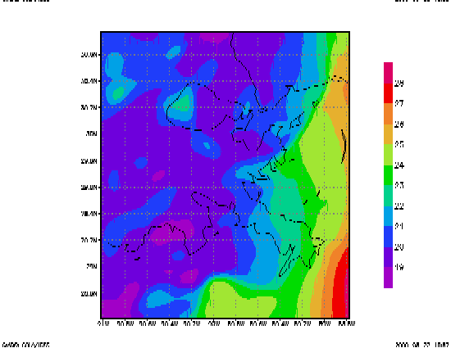
Figure 1a. Surface temperature (deg. C) on 24 July at 6 LST.

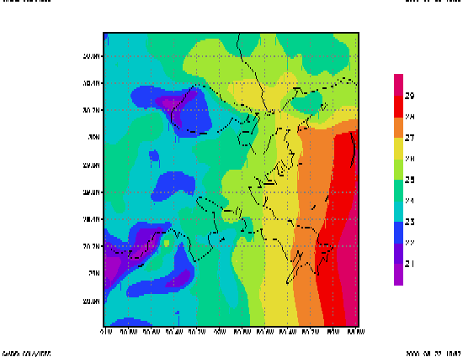

Figure 1b. The same as Fig. 1a, but at 12

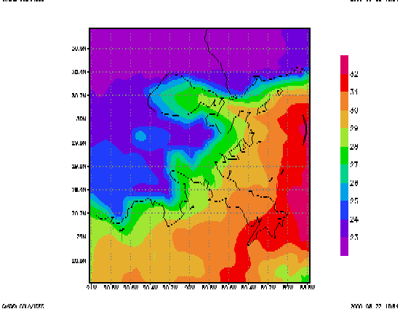Figure 2a. Surface temperature (deg. C.) on 17 August at 6 LST.
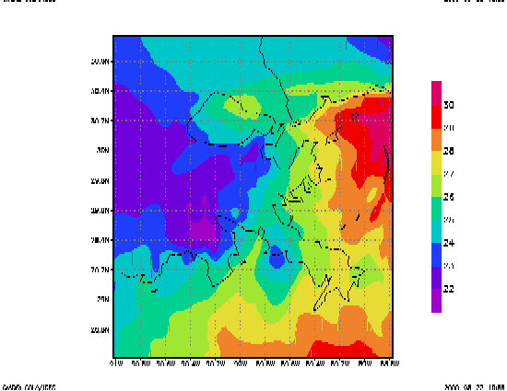
Figure 2b The same as Fig. 2a, but at 12 LST.

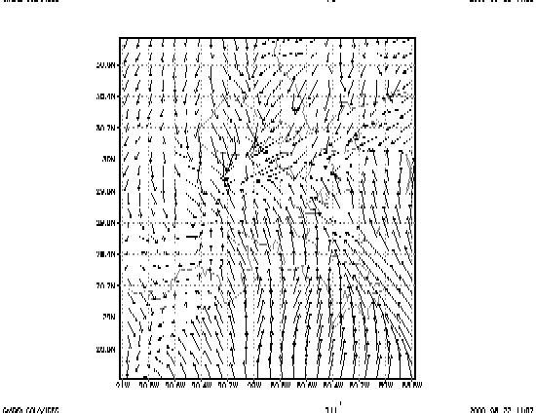
Figure 3a. Surface wind (m/s) on 24 July at 6 LST.
Figure 3b. The same as Fig. 3a, but at 18 LST.

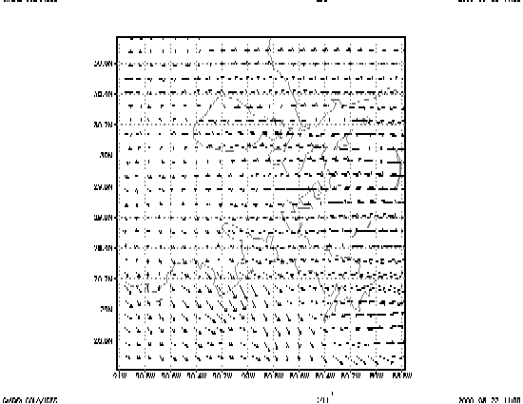Figure 4a. Surface wind (m/s) on 17 August at 6 LST.

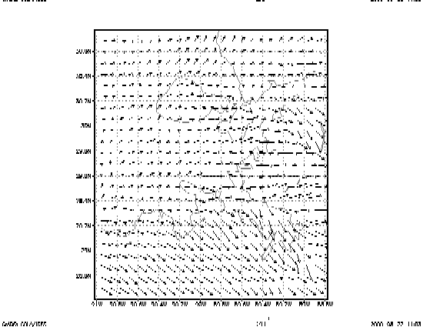
Figure 4b. The same as Fig. 4a, but at 18 LST.

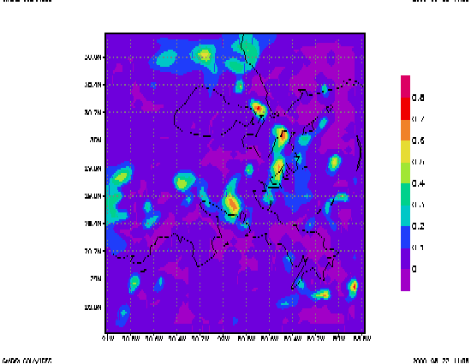
Figure 5. Cloudiness as cloud liquid water content vertically averaged between 1000 and 700 mb (g/kg) on 24 July at 18 LST.

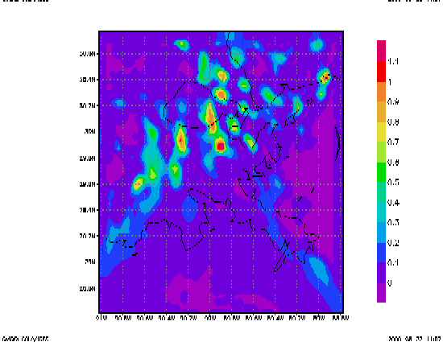
Figure 6. Cloudiness as cloud liquid water content vertically averaged between 1000 and 700 mb (g/kg) on 17 August at 18 LST.

