Numerical Simulation of Regional Climate with the Coupled MM5/SSiB Model

Weizhong Zheng and Da-Lin Zhang
Department of Meteorology, University of Maryland
College Park, MD 20742-2425
E-mail: zheng@atmos.umd.edu; dalin@atmos.umd.edu
Phone: (301) 405 - 2018, Fax: (301) 314-9482

Yong-Kang Xue
Department of Geography, University of California at Los Angeles
Los Angeles, California 90095-1524
E-mail: yxue@geog.ucla.edu

1. Introduction

Clouds and precipitation play an important role in the global water and energy cycle. However, despite significant progress in climate research, little work has been done to model explicitly the regional climate. Our ability to predict clouds and precipitation from diurnal to weekly and monthly scales is very limited due partly to the limited computing resources (or appropriate grid resolution to resolve local climate forcings) and realistic model physical representations (Kunkel et al. 1993; Giorgi 1991 ).

Previous modeling studies showed that the realistic simulation of cloud development depends strongly on land-surface processes interacting with cloud microphysics and larger-scale forcings. The representation of clouds/precipitation in atmospheric models depends on the grid resolution and relative significance of large-scale dynamics vs. local thermodynamic forcings (Zhang et al. 1988; Giorgi 1991), while the cloud development depends strongly on surface heat and moisture fluxes, which in turn are mainly determined by vegetation and soil moisture storage (e.g. Zhang and Fritsch 1988; Xue et al. 1996; Betts et al. 1996). However, current GCMs and regional climate models use a grid resolution of over 60 km with the convective precipitation paramterized (e.g. Giorgi 1991; Browning 1994). Clearly, such numerical models can only describe clouds/precipitation in terms of relative humidity at the very large mesoscale, and they will likely fail to predict rainbands,

line convection, orographically driven disturbances and precipitation as well as some mesoscale circulations.

In this study, we investigate the weekly to monthly predictability of clouds and precipitation over the LSA-East, defined roughly by 33 - 43⁰N latitude and 78 - 89⁰W longitude (GCIP 1997), by coupling MM5 with the simplified Simple Biosphere (SSiB) model of Xue et al. (1991, 1996). The LSA-East is selected, because its June 1998 was characterized by the passage of seven cyclones and the development of three mesoscale convective systems (MCSs), causing the regional widespread anomalous precipitation with local flooding conditions. Such frequent storm passage with moist lower troposphere suggests that surface evaporation from previous rainfall events may contribute significantly to the water cycle of the subsequent storms. Moreover, most of the precipitation appeared to be convective in nature, and generated by the frontal lifting and local surface conditions, thus exhibiting pronounced temporal and spatial variability in the storm development and rainfall distribution. The next section describes the model features Sections 3 shows the simulation results. A summary and concluding remarks are given in the final section.

2. Model description

The version 3.3 of MM5 is used for this study, which includes a multiple-nesting capability with nonhydrostatic dynamics. The SSiB model is used to represent land surface processes in MM5; it has three soil layers and one canopy layer with eight prognostic equations: volumetric soil moisture content in the three soil layers; temperature in the canopy, ground surface and deep soil layers; water stored in the canopy; and snow stored on the ground. Deardoff's force-restore method is used to predict the fast response (surface) and the slow response (deeper) soil temperatures. In the three-layer soil model, water movement is described by a finite-difference approximation to the diffusion equations. The governing equations for the interception water stores are based on water conservation equations.

Among various PBL schemes available in MM5, we choose MRF’s PBL scheme (Hong and Pan 1996), which is a local vertical diffusion scheme based on Troen and Mahrt (1986). In the coupled model, the diurnal varied surface albedo is calculated based on vegetation and soil properties, solar zenith angle, and snow. The effect of surface albedo on the reflected short wave radiation from the surface in turn influences the surface energy balance and surface skin temperature, which is related to canopy temperature and soil surface temperature. The effective ground temperature is used to derive the upward long wave radiation from the surface to the atmosphere. In cases of convective development, the short-wave radiation on the surface must be cut off in order to preserve the energy balance. Otherwise, false short wave radiation is received by the surface so that the surface temperature may go up continually.

In this study, a two-way, nested-grid (27/9 km) technique is employed to achieve multiscale simulations. A total of 23 levels in the vertical is used with the model top of 50 mb. The model water cycle includes the simultaneous use of the Grell convective parameterization and simple ice microphysics package for the 27- and 9- km grid meshes.

Although we plan to eventually use GCM forecasts to provide the needed lateral boundary conditions for the coupled MM5/SSiB model, we choose, as a first step, to specify the outermost lateral boundary conditions using NCEP’s Eta analysis. The Eta analysis consists of gridded data at a resolution of 40 km on the AWIPS-212 grid. It covers North America from about 18 to 60⁰N. To effectively test the impact of different land-surface schemes, various trial runs were conducted and examined with only one coarse-mesh domain

3. Results

Figure 1 compares the LSA-East-averaged daily precipitation during the month of June 1998 among different runs. Obviously, most experiments can capture every rainfall event. In general, the runs with the SSiB scheme perform better than those with the OSU scheme. During the first few days, both the MLS and OSU schemes produce more precipitation than the observed, but poorly the rainfall peaks at the right time after two weeks. The SSiB scheme using 9-km resolution captures more reasonably the observed precipitation than the one with 27-km resolution.

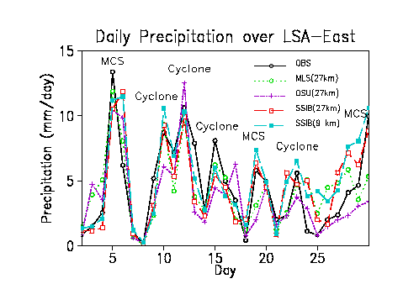
Fig. 1 Comparison of the LSA-East-averaged daily precipitation.

Figure 2 indicates the LSA-East-averaged daily max/min surface temperature between the observed and simulations obtained using the SSiB with the 27-km and 9-km grid sizes. Both simulations are similar, and they are in reasonable agreement with the observed. However, the simulated minimum surface temperatures seem to be somewhat warmer than the observed.

In order to further compare the results with
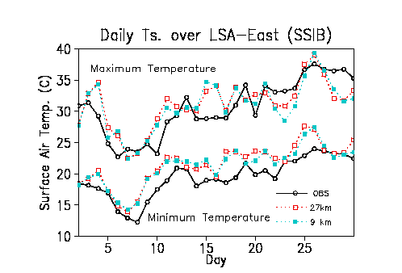
Fig. 2 Comparison of the LSA-East-averaged max/min surface. temperature.

different schemes, we focus on their rainfall distributions over the LSA-East. Figure 3 shows the monthly averaged precipitation. The heavy rainfall occurs in the Tennessee River basin, western Appalachian Mountains over West Virginia and central Indiana (Fig. 3a). There is an area of small rainfall in the west of the LSA-East. Both the MLS and OSU schemes fail to reproduce this rainfall pattern. The heaviest rainfall appears over the western part of the LSA-East. The SSiB scheme reproduces well two heavy rainfall regions in western Appalachian Mountains in West Virginia and central Indiana but under-predicts the one in the Tennessee River basin. The simulated pattern with the 9 km grid size is similar to the one with 27 km, but the rainfall is closer to the observed and the location of the heavy rainfall region in western Appalachian Mountains is better reproduced.
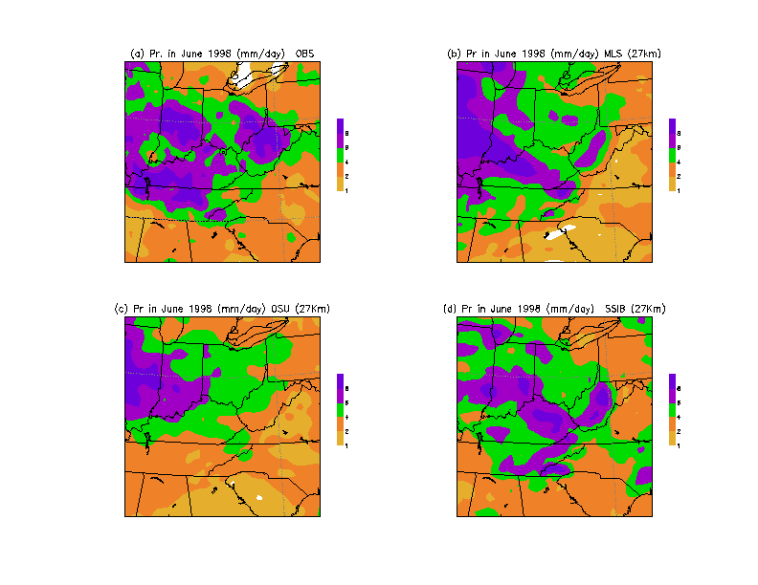

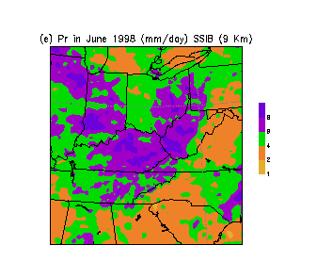

Fig.3 Comparison of (a) the observed precipitation in June 1998 (mm/day) to those simulated from (b) MSL; (c) OSU; (d) SSIB with 27-km grid size and (e) with 9-km grid size.

The weekly simulations using the SSiB scheme indicate that during the first week, the main heavy rainband occurs in the Tennessee River basin and another smaller rainband on the upwind side of the Appalachian Mountains. The 9-km simulation reproduces reasonably those rainbands but over-predicts the rainfall in the central Appalachian Mountains. There were two banded precipitation regions during the second week. Both simulations with 27 km and 9 km capture the northern one but fail to reproduce the southern one. Although the 9 km simulation produces a precipitation band in the Tennessee River basin, the location is too much to the north and the intensity is too weak compared to the observed. The SSiB scheme can also reproduce reasonably the rainfall pattern during the third and fourth week, especially for the 9 km simulation. However, the model produces more rainfall over the southern part of the LSA-East during the fourth week.

4. Summary and conclusions

The coupled MM5/SSiB model was used to study the regional climate at weekly to monthly time scale. Some preliminary results were obtained. We have demonstrated that the model produces a realistic simulation of the climate conditions over the LSA-East. The simulated climate variables are sensitive to the grid resolution and model physical processes. In general, the simulations with higher grid resolution are in better agreement with the observations.

Acknowledgments
This work was supported by the NOAA/GCIP Grant NA96GP0277. The computations were performed at the Department of Meteorology/University of Maryland.

References

Betts, A.K., J.H. Ball, A.C.M. Beljaars, M.J. Miller and P. Viterbo, 1996: The land-surface-atmosphere interaction: A review based on observational and global modeling perspectives. J. Geophys. Rev., 7209-7225.
Browning, K.A., 1994: Survey of the perceived priority issues in the parameterization of cloud-related processes in GCMs. Q. J. Roy. Meteor. Soc., 120, 483-487.
GCIP, 1997: Major Activities Plan for 1998, 1999 and Outlook for 2000 for the GEWEX/GCIP, IGPO Pub. Series 26.
Giorgi, F., 1991: Sensitivity of simulated summertime precipitation over the United States to different physics paramterizations. Mon. Wea. Rev., 119, 2870-2888.
Hong, S.-Y. and H.-L. Pan, 1996: Nonlocal boundary layer vertical diffusion in a mediumrange forecast model. Mon. Wea. Rev., 124, 2322-2339.
Kunkel, K.E., S.A. Changnon and R.T. Shealy, 1993: Temporal and spatial characteristics of heavy-precipitation events in the Midwest. Mon. Wea. Rev., 121, 858-866.
Troen, I., and L. Mahrt, 1986: A simple model of the atmospheric boundary layer: Sensitivity to surface evaporation. Bound.-Layer Meteor., 37, 129-148.
Xue, Y., P.J. Sellers, J.L. Kinter, and J. Shukla, 1991: A simplified biosphere model for global climate studies., J. Climate, 4, 345-364.
Xue, Y., M.J. Fennessy, and P.J. Sellers, 1996: Impact of vegetation properties on U.S. weather prediction. J. Geophys. Res., 101, 7419-7430.
Zhang, D.-L., E.-Y. Hsie and M.W. Moncrieff, 1988: A comparison of explicit and implicit predictions of convective and stratiform precipitating weather systems with a meso-b scale numerical model. Quart. J. Roy. Meteor. Soc., 114, 31-60.
Zhang, D.-L., and Fritsch, 1988: Numerical sensitivity experiments of varying physics on the structure, evolution and dynamics of two mesoscale convective systems. J. Atmos. Sci., 45, 261-293.

