Streamflow and Snowpack Forecasting in the Pacific Northwest using MM5 and a Distributed Hydrology Model

Kenneth Westrick
Pascal Storck
Clifford Mass

Department of Atmospheric Science, Box 351640,
University of Washington, Seattle, WA 98195
E-mail westrick@atmos.washington.edu

1. Introduction
Urbanization, population growth, climate change, and other factors, will continue to place an increasing burden on water resources throughout the world. Although it is often perceived as having an abundance of water, the Pacific Northwest region of North America is not immune to this dilemma. The needs of the various economic (hydropower, irrigation, etc.), ecological (sustainment of fish flows), societal (human consumption), and political (maintaining water rights) interests will further require that water treated as a precious commodity here as well as throughout the world.
The increasing value placed on water will require a renewed emphasis on optimal management of this dwindling resource, including the planned storage and release of water from reservoirs. In the future, managers will increasingly be called upon to manage this resource ‘at the margin’ (e.g., holding back water for future use), which increases the likelihood of inadequate preparation for flood events. This highlights the need for accurate streamflow forecasting, at both short-term (days-weeks) and long-term (weeks-months) time scales.

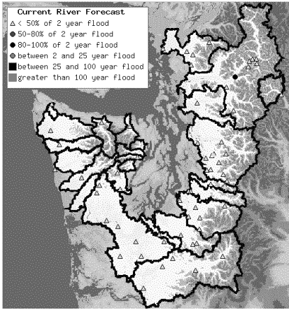
Figure 1 - Current operational area of the UWHIPS system.
2. Description
Since autumn, 1998, the University of Washington has operated a forecasting system that provides short-term (60 hour) streamflow and snowpack predictions for a substantial region of Washington State. The University of Washington hydrologic information and prediction system (UWHIPS) is based on the Penn State – NCAR mesoscale model MM5 and the distributed parameter hydrology model DHSVM (Wigmosta 1994). MM5 forecast data, including temperature, wind, radiation, and precipitation, are downscaled to the high resolution (150 meter) of the hydrological model using a variety of statistical and dynamical algorithms. Currently the system produces forecasts for over 70 USGS gauge locations in 26 watersheds in western Washington (Figure 1). The forecasts are then used by a number of regional entities, including the National Weather Service, Seattle City Light utility, and various other public and private agencies and firms.
In addition to real-time streamflow forecasting (Westrick et al, in review), the UWHIPS has also been used for a variety of other applications, including diagnosis of flood events (Westrick and Mass 2001), identifying MM5 model precipitation biases (Westrick and Mass 1999), and snowpack prediction and assessment (Westrick and Storck 2000). The system is also currently being tested for use in conjunction with various extended streamflow prediction (ESP) strategies.
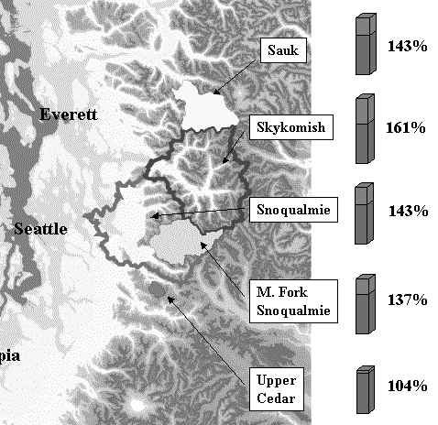
Figure 2 - Long-term MM5 precipitation biases (4 km resolution) for various watersheds in western Washington using a water balance approach and incorporating a distributed parameter hydrology model (from MM5 Workshop 1999).

3. Results
A relatively long verification period has allowed for a detailed assessment of the MM5-DHSVM system. Strengths and weaknesses in both the modeling system and verification methods have been identified. An area of continued emphasis has been the identification and mitigation of the MM5 precipitation bias, previously identified by Colle et al (1999, 2001). This overprediction bias, which principally occurs on the windward side of major orographic barriers, has been also confirmed using the UWHIPS system (Fig. 2).
A short-term approach to reduce this precipitation bias is to apply spatial correction algorithms to the MM5 precipitation fields. This approach was tested over a six-month period of cool-season (Oct-Mar) forecasts produced by MM5, with limited success. Substantial improvements were noted in the long-term water mass balance, as determined by total runoff at various USGS gauge locations, thus indicating that this correction may be useful for long-term (e.g., climate scale) simulations where mass balance is paramount. Unfortunately, degradation in peak flow forecasts was noted, another indicator that the precipitation bias is temporally intermittent.
Another method for reducing the precipitation bias is the use of other microphysical schemes. An assessment of UWHIPS forecasts for WY 2001, which were based on MM5 physics ensembles (Grimit and Mass, in review) have indicated that the precipitation bias may be reduced by using more sophisticated microphysical schemes. Although a point verification of precipitation forecasts is yet to be conducted, early results suggest substantial improvement from using the Reisner II microphysics scheme, especially in watersheds located on the lee of major orographic barriers.

4. Summary

The University of Washington hydrologic information and prediction system (UWHIPS) is based on the Penn State-NCAR mesoscale model MM5 and the University of Washington-Battelle distributed hydrology soil vegetation model DHSVM. The system has been used for snowpack and streamflow diagnosis and real-time prediction in the Pacific Northwest since 1997. Flow forecasts have confirmed deficiencies previously detected in MM5 precipitation forecasts. Time independent spatial correction algorithms, which reduce this bias, may be applicable for long-term studies but degrade individual peak flow forecasts. Early indications are that more sophisticated microphysical schemes may be superior to simpler schemes, especially in watersheds immediately in the lee of major orographic barriers. This preliminary finding needs to be confirmed through a more thorough analysis. Future UWHIPS research will focus on the previously discussed questions, as well as other topics related to water resources, hydropower optimization, and extended streamflow prediction.

References

Colle, B.A., K. J. Westrick, C. F. Mass, 1999: Evaluation of the MM5 and Eta-10 precipitation forecasts over the Pacific Northwest during the cool season. Wea. Forecasting, 14, 137-154

Colle, B.A., C.F. Mass, and K.J. Westrick, 2001:MM5 Precipitation verification over the Pacific Northwest during the 1997-1999 cool seasons. Accepted by Wea. Forecasting.

Grimit, E.P., and C.F. Mass. Initial Results of a Mesoscale Short-Range Ensemble Forecasting System over the Pacific Northwest. Submitted to Wea. Forecasting.

Westrick, K.J., C.F. Mass, and D. McDonnal, 1999: Description and Results from a Coupled Real-Time Riverflow Forecast System. Presented at the MM5 Users Workshop.

Westrick, K.J., and P. Storck, 2000: Evaluation of the MM5-DHSVM Streamflow Forecast System in the Pacific Northwest. Presented at the Western Snow Conference.

Westrick, K.J., and C.F. Mass, 2001: An evaluation of a high-resolution hydrometeorological modeling system for prediction of a cool-season flood event in a coastal mountainous watershed. J. Hydrometeor. 2, 161-180.

Westrick, K.J., and C.F. Mass: Description and Evaluation of a Hydrometeorological
Forecast System for Mountainous Watersheds. Submitted to Wea. Forecasting.

Wigmosta, M. S., Vail, L. W., and Lettenmaier, D. P., 1994: A distributed hydrology-soil-vegetation model for complex terrain. Water Resour. Res., 30, 1665-1679.

