DOWNSTREAM Science Overview

**1. Background**

Rossby waves require a horizontal gradient of potential vorticity (PV) on which to propagate. The distribution of PV in the atmosphere tends to be concentrated meridionally into regions referred to as waveguides (Fig. 1a), the idea being that the location of the gradient constrains how synoptic-scale Rossby waves propagate. Once excited within the waveguide region, these waves propagate downstream, often producing high-impact weather with the potential for significant loss of life and damage to property and adverse economic consequences.

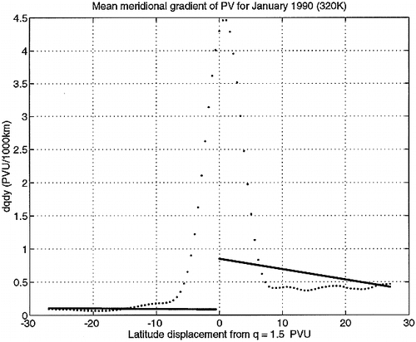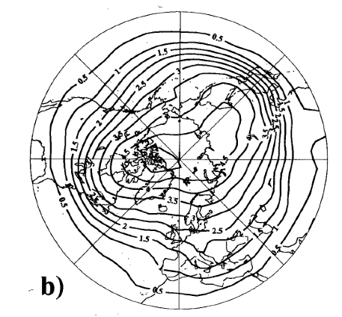

Figure 1. (a) Zonal mean meridional gradient of potential vorticity relative to the location of the 1.5 PVU contour of PV on the 320 K isentropic surface (after Morgan and Nielsen-Gammon 1998); (b) the Eulerian time mean PV on the 315 K isentropic surface (after Brunet et al. 1995) (PVU). 1 PVU = 10-6 m2Kkg-1s-1.

**a)**

The waveguide generally defines the quasi-horizontal (on an isentropic surface) separation of tropospheric and stratospheric air (Fig. 1). This gradient tends to be sharp when evaluated relative to the tropopause (hence the term “waveguide”), but appears rather diffuse in the Eulerian time mean because of meridional excursions of the region of strong gradient (Fig. 1b). From a planetary-scale perspective, there exists a systematic meridional gradient of potential vorticity on isentropic surfaces, or equivalently, a systematic gradient of potential temperature on a surface of constant potential vorticity. Within the broad zone of potential temperature contrast are troughs and ridges, each with their own local concentrations and dilutions of the potential temperature gradient, accompanied by corresponding strengthening and weakening of winds on the tropopause.

While often idealized as a single band of PV gradient, there is often more than one such gradient region at a given longitude. For instance, on many days it is possible to identify the subtropical, mid-latitude and arctic gradient regions, and these can have different spatial relationships relative to each other. Wave trains are easily observed to propagate along the waveguide region. In many cases, the rotational flow associated with baroclinic eddies dominates the advection of PV and hence the propagation mechanism for the waves. Operational weather prediction systems have matured to the point that large errors are rare in the medium range (4-8 days) associated with “quasi-adiabatic” downstream propagation of waves.

In the mid-latitudes, the waveguide sharpens as plumes of tropical or subtropical moist air are periodically injected into the mid-latitude flow. On some occasions, those injections occur due to poleward moving tropical cyclones, but more often, they are associated with meridionally elongated baroclinic waves. These often represent instances where the subtropical and mid-latitude PV gradient regions nearly coalesce into a single intense jet.

Poleward moisture plumes (also referred to as warm conveyer belts) are interesting for a variety of reasons. First, the extent of diabatic heating in the poleward flowing air originating in the tropics or subtropics directly affects the structure and strength of the PV gradient and hence the strength of the mid-latitude jet. Strong jets are often associated with larger amplitude downstream features (greater potential energy) and more rapid movement and evolution of such features. Both contribute to larger forecast errors.

Second, the proximity of clouds, with radiation and microphysical processes, within the waveguide region suggests that the evolution of the waveguide depends on these processes that are difficult to represent, and whose physics is not well understood or observed. In addition, because moisture plumes reach tropopause laterally owing to its downward slope with latitude, diabatic processes and turbulence near the jet allow transport of trace constituents across PV contours and into the lower stratosphere. We hypothesize that tropical plumes represent a “window” of transport during which the PV barrier is vulnerable in some sense.

Trace constituents are also important indicators of source regions of air. Understanding the source regions, and thermodynamic properties of these regions, can provide important observational constraints on diabatic heating and can help us “tag” air masses that we might observe at later times in the waveguide region. Constituents such as dust (and other aerosols) can help us understand the microphysical processes in clouds within moisture plumes. In turn, knowing how the microphysics is operating helps interpret the vertical mass flux profiles we see.

Third, one of the largest uncertainties in models is the representation of the aggregate effects of condensation (and fusion) heating. Poleward-moving tropical air masses, whether associated with tropical cyclones or not, feature widespread deep convection. A crucial influence of these air masses on mid-latitude dynamics is through the divergent outflow in the upper troposphere. However, the region of the waveguide often features a complex, layered structure in the details of the PV distribution. Similarly, the detailed vertical mass flux profile of precipitating regions determines the detrainment altitude and structure. It is the combination of the two factors, the distribution of PV (that one might measure prior to the arrival of tropical plumes) combined with the details of the outflow vertical profile that are hypothesized to determine the nature of the waveguide response. Significant errors can be made in both the PV and outflow properties.

The vertical structure of convectively-induced outflow and the orientation and structure of the waveguide are also influenced by precursor disturbances originating at relatively high-latitudes. Whereas baroclinic disturbances on a variety of scales influence poleward moisture transport and the shape of the waveguide, we focus herein on mesoscale tropopause disturbances. Owing to their relatively small scale and dependence on radiative processes for their intensity, we hypothesize that relatively large forecast errors can result from the mis-representation of these features as the enter the waveguide region.

The result of errors in diabatic heating can have significant implications for downstream prediction. This represents a well-known forecast concern for Europe, and similar processes over the western Pacific present forecast challenges over North America. However, events like hurricane Sandy (2012) represent cases in which the diabatic heating and outflow that the tropopause present serious forecast challenges for the eastern U.S. and the Maritime Provinces of Canada.

While motivated by a desire to provide key measurements that can reduce the errors in forecasts of high-impact weather events, the present proposal is primarily a study of the physical processes at work near the mid-latitude tropopause. The emphasis on the intersection of baroclinic dynamics, clouds, radiation and chemistry and the focus on how these processes operate down to the kilometer scale or less, means that our results will aid the advance of weather and climate models alike.

**This section needs more about previous research, and it needs numerous references**

**2. Phenomena of Interest**

The meteorological phenomena of interest in the present study are summarized below to provide a context for the hypotheses and field deployment strategies. These phenomena involve different configurations of the waveguide at the tropopause, but the common element of each is the potential for inducing large-amplitude meridional displacements of the tropopause and downstream development of those displacements.

Figure 2. Maps of potential temperature on the dynamic tropopause (shaded, K), winds on the DT and relative vorticity at 850 hPa (contours, cyclonic vorticity only). Black oval represents the approximate range of the GV from St. John’s Newfoundland. (a) a diabatic Rossby Vortex; (b) a tropopause polar vortex; (c) extratropical transition; and (d) poleward moisture plume (also known as a warm conveyor belt).

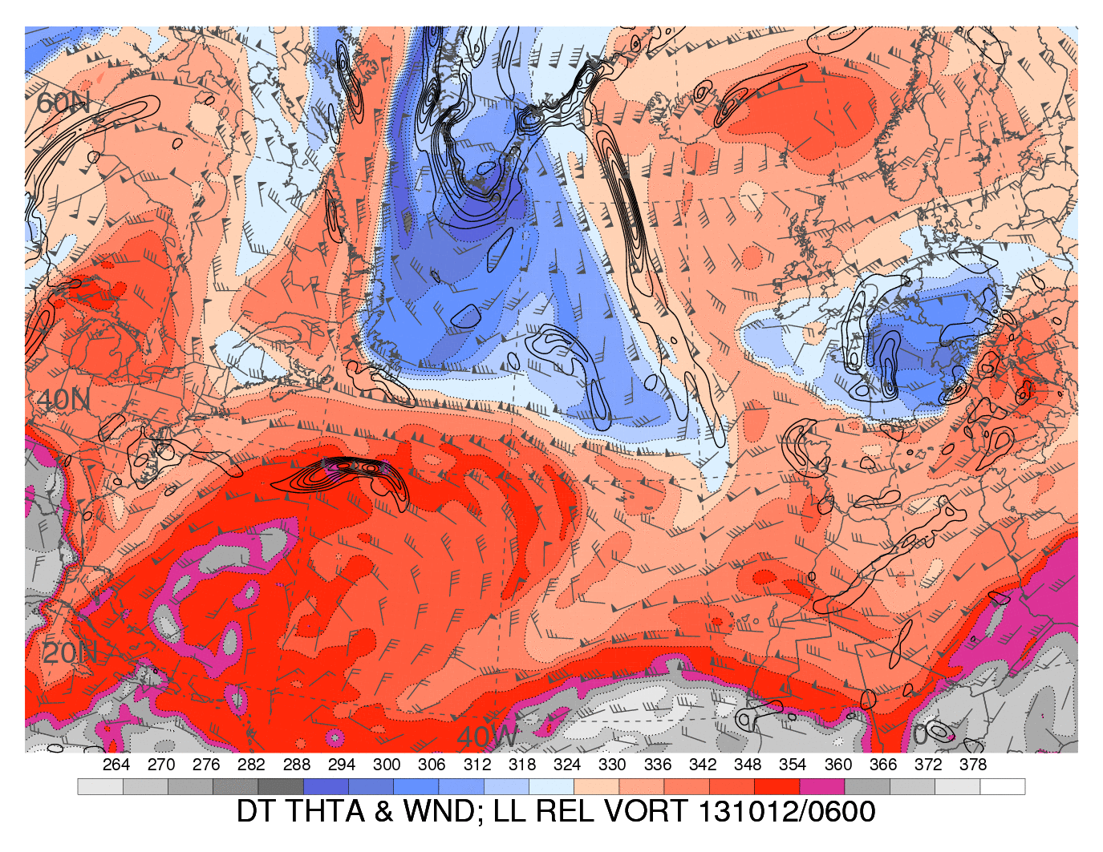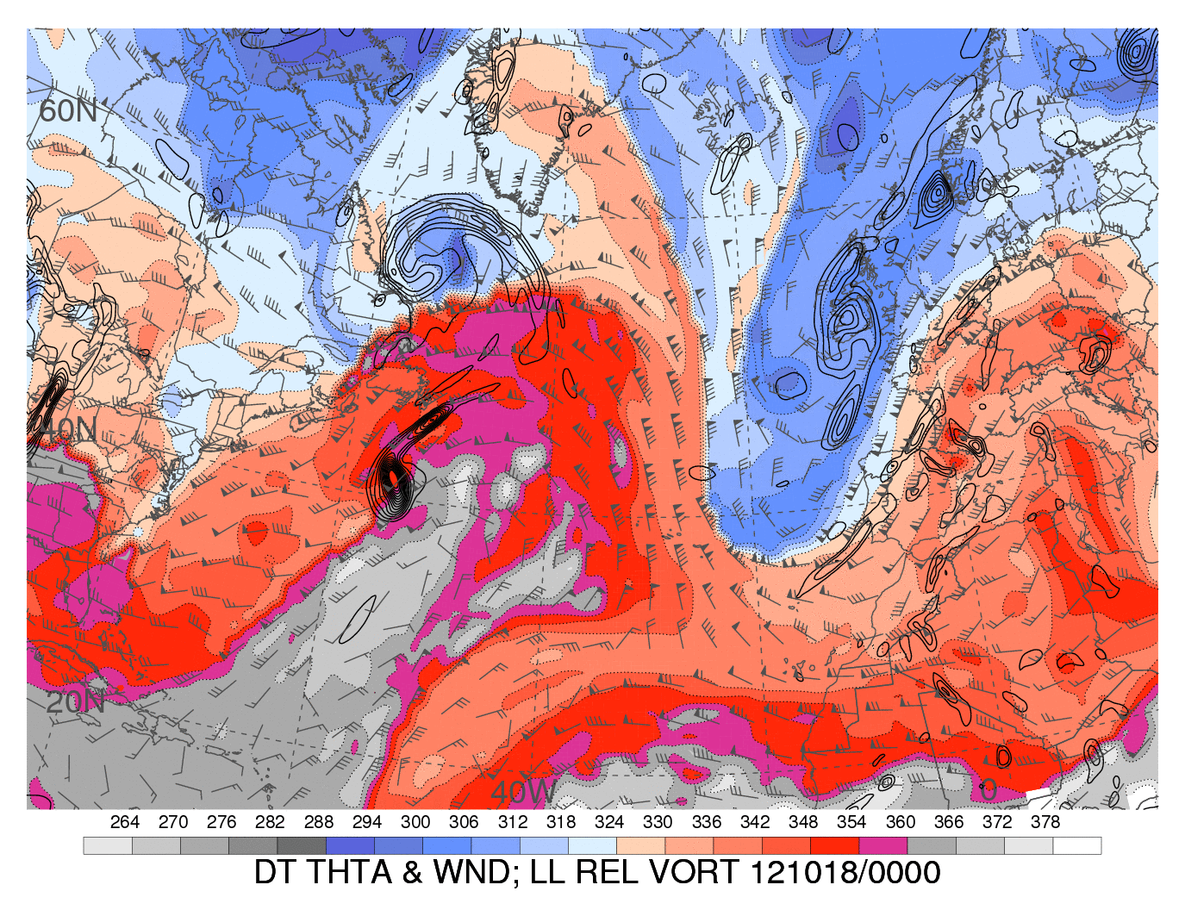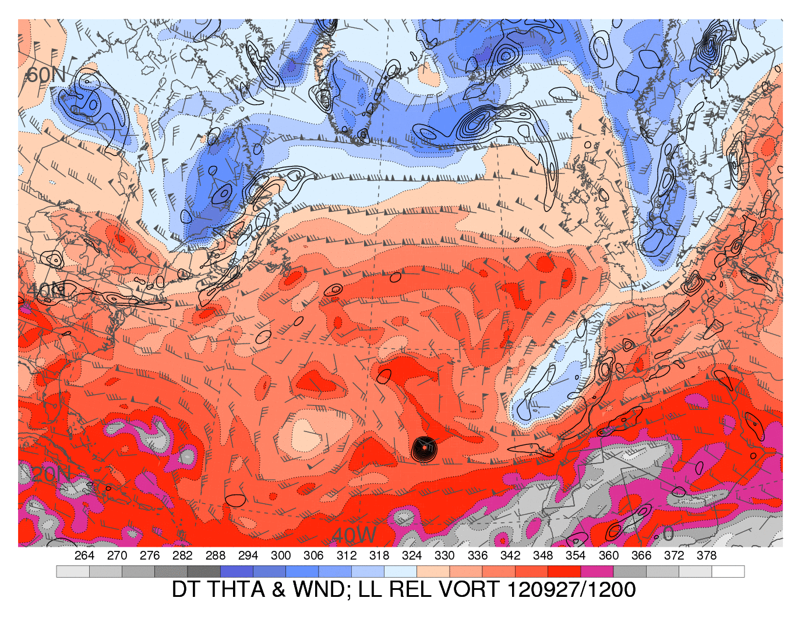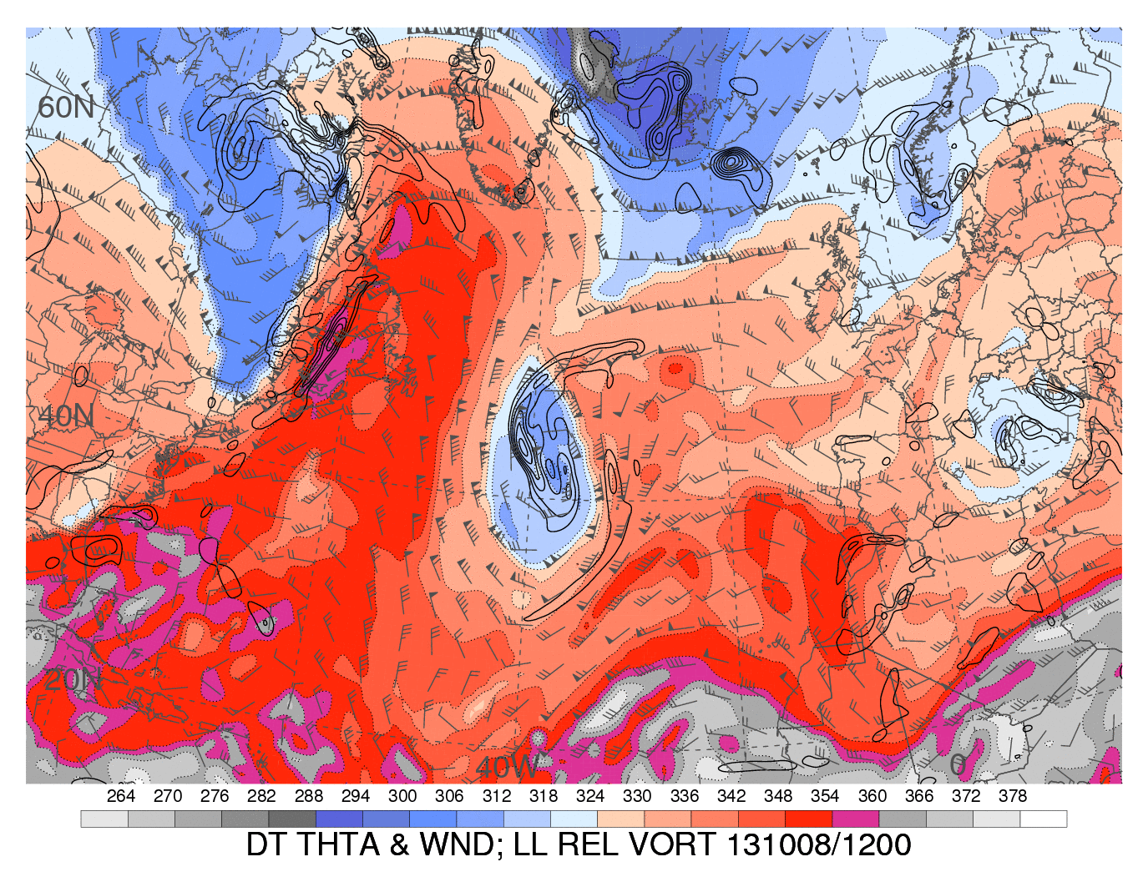

**1**

**2**

**3**

**4**

(a)

(b)

(c)

(d)

Figure 2a shows a shallow cyclonic circulation feature developing beneath a ridge on the tropopause. This represents a diabatic Rossby vortex (DRV) and is one of the ways that diabatic heating leads to waveguide perturbations that would not exist in adiabatic flows. The DRV can amplify through diabatic heating and perturb the tropopause, sometimes resulting in a deep, intense cyclone downstream. The particular event is shown at 06 UTC 10 October 2013. Three days later, the DRV had become a tropospheric-deep, moderately intense cyclone to the west of the U.K.

In Fig. 2b is shown a tropopause polar vortex (TPV) over eastern Canada at 12 UTC 27 September 2012. The scale of this feature (roughly 500 km across) and the isolation of low values of potential temperature mark this as a possible TPV. In this particular case, the absence of a strong synoptic-scale tropopause jet and PV gradient meant that the downstream effects of this TPV were modest.

A case where a TPV is juxtaposed with a plume of tropical air is 12 UTC 8 October 2013, shown in Fig. 2d. The low-potential-temperature region comprises two TPVs that merged (according to the analysis) during the previous day. This case features a rapid poleward expansion of the anticyclone on the DT beyond 60N latitude and a strong mesoscale cutoff cyclone over Europe 3-5 days later.

The last case is the extratropical transition (ET) of hurricane Rafael, shown here at 00 UTC 18 October, 2012 (Fig. 2c). This case also resulted in a strong trough downstream over Europe. Rafael itself did not intensify significantly during ET. The moisture plume in this case was notably greater than with the case on the lower left, and tropopause potential values were correspondingly larger as well.

The cloud shield associated with the ET of Rafael (Fig. 3) shows several features that have counterparts in potential temperature on the DT. Cloud shield ‘1’ is associated with the anticyclonic vorticity over Greenland that does not appear to be directly related to the ET. Cloud shield 2 appears on the northeast edge of the high potential temperature air on the DT. Cloud area ‘3’ represents the cloud band associated with the apparent warm front (depicted by the elongated vorticity to the northeast of the cyclone center in Fig. 1) along with the remnant convective clouds near the center of Rafael. Cloud are 4 is a streamer with embedded deep convection that is coincident with the highest potential temperatures on the DT. Each of these cloud features represents the focusing of ascent by different mesoscale processes and different cloud and radiative processes owing to the differences in temperature and air mass origin. Each of these regions would potentially have a distinct effect on the waveguide (or waveguides in this case) and the potential for distinct downstream effects.

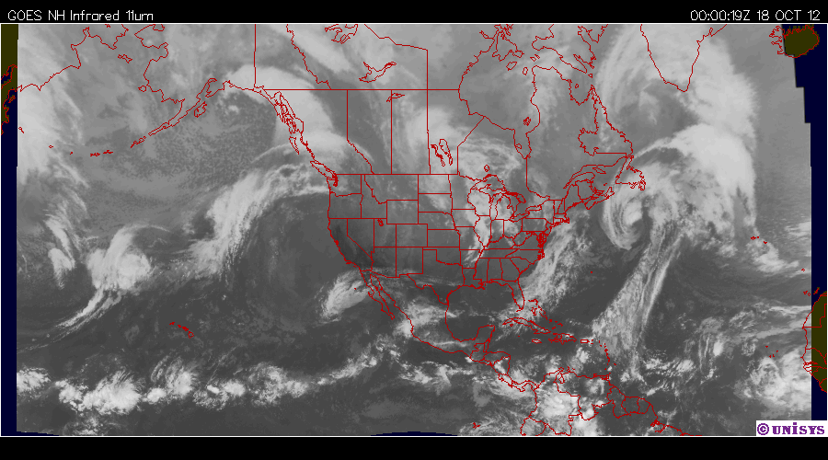

**1**

**2**

**3**

**4**

Figure 3. Infrared satellite image at 00 UTC 18 October 2012.

**3. Science Themes and Hypotheses:**

The science themes of DOWNSTREAM are focused on the processes operating across multiple scales in the waveguide region. The scales considered are represented schematically in Fig. 4. These themes may be grouped broadly into microscale processes that are difficult to observe and model, but which have effects on the mesoscale features near the jet stream. These processes are modulated by the distribution of water, in all of its forms, throughout the troposphere in the regions of strong baroclinicity that accompany the jet. The representation of microscale processes has implications for long-time-scale errors in models as well, especially concerning the cloud-radiative effects.

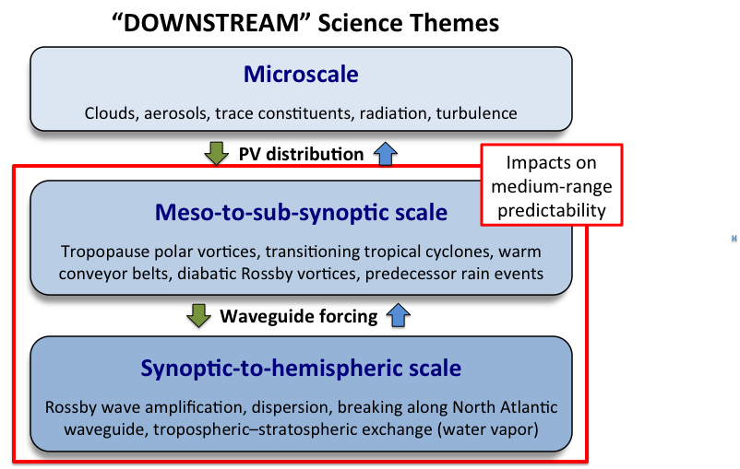

Figure 4. Schematic of the different spatial and temporal scales of phenomena embodied by the science objectives of DOWNSTREAM.

The red box in Fig. 4 encloses the scales the bear most directly on predictability issues in the medium range. The focus of the dynamical scientific objectives lies in the middle box. We anticipate that global analyses are adequate to represent processes on synoptic-to-hemispheric scales as a context and environment for smaller-scale processes. However, such “large-scale” processes may be influenced significantly by mesoscale errors at long time ranges (5 days or more).

Related to the science themes, the following hypotheses motivate the observations to be collected by DOWNSTREAM (see Sec. 4 for observing strategy).

1. Large errors in downstream prediction originate from perturbation of the waveguide by the divergent flow associated with deep convection in tropical or subtropical moisture plumes (either associated with tropical cyclones or not).

Sub-hypothesis: Divergent outflow dominates rotational flow in producing waveguide perturbations that lead to significant forecast errors.

Sub-hypothesis: It is not the outflow from the tropical cyclone per se that matters, but rather, the integrated mass flux of convection on the periphery of the cyclone associated with frontal ascent and convection that determines the essential outflow characteristics.

2. Predictability of waveguide perturbations and their downstream evolution is most limited by lack of knowledge of the vertical mass flux within precipitation regions near the waveguide and the vertical profile of the outflow relative to the PV gradient region.

Sub-hypothesis: The outflow profile results from thermodynamic influences (mainly the large-scale relatively humidity and convective instability in the lower-mid troposphere and microphysical processes (including effects of aerosols).

3. Tropical moisture plumes represent windows for large amounts of water vapor (and other trace constituents) to be injected into the lower stratosphere.

4. Tropopause polar vortices (TPVs) are intensified mainly through radiative effects.

Sub-hypothesis: Because of limitations of thermodynamic data in polar regions, the mesoscale nature of TPVs and their dependence on diabatic processes, they constitute an important source of forecast uncertainty when they approach a PV gradient region.

5. The formation of extensive cirrus shields, with their associated diabatic heating and radiative processes, can significantly modify the PV in the waveguide region, and can assist in transport of trace species into the lower stratosphere.

Sub-hypothesis:

**Hypotheses need revising and possibly expanding.**

**4. Observation Strategy**

The primary observing platform for DOWNSTREAM is the NSF/NCAR Gulfstream V (GV) aircraft. The location that offers the best chance of sampling the phenomena of interest would be over extreme northeastern North America. We suggest St. John’s Newfoundland as a base of operations. Assuming mission durations of at least 8 hours, depending on details of the payload, this location allows us to reach the subtropical Atlantic to the south and Greenland to the north. The subtropical, mid-latitude and polar jets will generally be within range (here defined as approximately 2000 km) from this location. Prediction errors arising in this area affect Europe within 2-5 days. This base allows sampling of tropical moisture plumes and extratropical transition events that directly affect eastern North America.

The months of September and October offer the best chance of observing the influence of strong diabatic heating within tropical moisture plumes impinging on the waveguide in the mid-latitudes owing to the still-warm Atlantic waters combined with increasing baroclinicity as the polar regions cool. The peak in Atlantic extratropical transition occurs in September (Hart and Evans 2001) whereas the climatology of warm conveyor belts (Madonna et al. 2013) shows that they are more common in winter than in summer because of their dependence on baroclinic waves. In addition, the cooling of polar regions and southward migration of the polar jet increases the likelihood of TPVs forming and moving out over relatively warm Atlantic waters. September and October therefore represent a period when each phenomenon of interest is likely to occur. From the perspective of downstream weather over Europe, autumn is noted for historic wind and flood events.

We propose an extensive set of instrumentation for the GV to address the scientific hypotheses. These instruments are summarized in Table 1. We propose 170 flight hours covering a 45-day period from September 15 to October 31 2016. During the two-week period from October 1 to October 14, we propose to use two crews to allow flights on numerous consecutive days, or potentially two flights on the same day. The instrumentation proposed on the GV appears in Table 2.

|  |  |
| --- | --- |
| **HAIS instruments** | |
| Vertical Cavity Surface Emitting Laser Hygrometer (VCSEL) | Measurements of water vapor concentration |
| Fast Ozone Instrument | Quantification of ozone mixing ratio |
| Cloud Particle Imager (CPI) | Images of particles at orthogonal views |
| Microwave Temperature Profiler (MTP) | Temperature profile |
| *High Spectral Resolution Lidar (HSRL)* | *Vertical cross sections of cloud and aerosol optical depth* |
| HIAPER Cloud Radar (HCR) | W-band, scanning beam (up and down, orthogonal to aircraft) |
| Trace and Organic Gas Analyzer (TOGA) | Measurement of oxygenated volatile organic compounds and nonmethane hydrocarbons |
| HARP Spectral Irradiance | Visible and near-IR fluxes up/down |
| **Non HAIS Instruments** | |
| Counterflow Virtual Impactor (CVI) | Air intake for sampling large particle composition |
| Particle Analysis by Laser Mass Spectrometry | Ice cloud particulate matter (PALMS) |
| Dropsonde System | 700 dropsondes (20 flights at approximately 35 dropsondes per flight) |
| UHSAS | Sub-micrometer aerosol size distributions |
| CDP | Cloud droplets, possibly frozen |
| 2D-C | Precipitation particles |
| Kipp & Zonen pyrgeometers | Long-wave radiative fluxes (up/down) |
| Radome 3D-wind system and state parameters | Turbulent eddy dissipation rate |
| Laser Air Motion System (LAMS) | High-accuracy wind |
| Differential GPS (XP accuracy) | Aircraft altitude, difference from pressure altitude (D-value) |
| **CARI Instruments** | |
| PICARRO | Airborne measurement of CO2 and CH4 |
| CO | Vacuum fluorescence instrument for measurement of carbon monoxide |
| *NOx* | *Two-channel chemiluminescence instrument for measurement of NOx* |
| Table 2. Instrumentation proposed for DOWNSTREAM. Instruments in italics are desired, but optional. | |
|  | |

In Fig. 5, an example is provided in which the G-V flies from St. John’s, Newfoundland to a region of deep tropical moisture and convection. The diabatic-driven divergent outflow associated with the convection perturbs the upper-level jet. Then, the aircraft makes several transects of the jet stream. At the end of the final crossing of the jet stream, the aircraft may either return to St. John’s or forward deploy to Shannon Ireland, which allows for a follow-on mission the next day as the target system moves eastward.

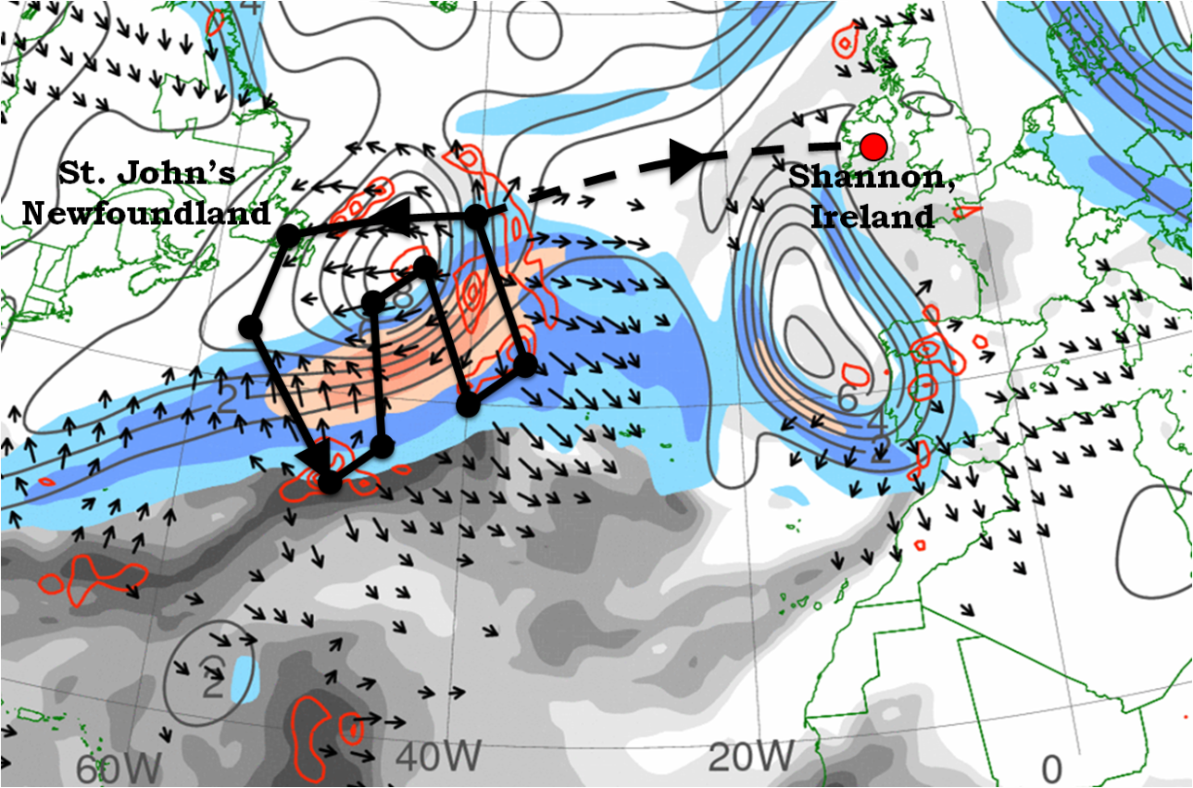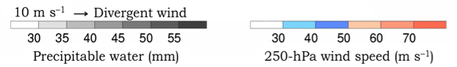

Figure 5. Sample DOWNSTREAM G-V observing mission displayed with precipitable water (mm, gray shaded), 250 hPa wind speed (m s-1 color shaded), divergent wind (m s-1, scale in lower left), and potential vorticity (contours at 1 PVU interval), and 550-450 hPa layer-averaged ascent contoured at 5 x 10-3 hPa s-1 for 1800 UTC 27 September 2013.

In addition to flight operations over the North Atlantic, flights over regions of the Canadian Arctic, Hudson Bay, and Labrador Sea would be desired to satisfy specific science objectives. In support of these missions, permission for deploying dropsondes over land in the Canadian Arctic may be requested.

The flight plan in Fig. 5 would be approximately 3442 nautical miles, returning to St. John’s. We also consider an option to forward deploy to Shannon, Ireland (or another nearby location) so that a flight into the system is possible on the following day. This option will be carefully considered in collaboration with the staff at the NCAR Research Aviation Facility.

The pattern shown in Fig. 5 crosses the jet four times, nominally at an altitude of 40,000-42,000 feet. We recognize that the density of air traffic at certain times of the day will require careful coordination and planning of flights. Analysis of commercial trans-Atlantic flight traffic indicates windows of relatively modest air traffic between 40W and 60W in the pre-dawn hours and during the early afternoon. Westbound traffic from Europe (morning and early afternoon) will tend to avoid the strongest westerlies. Furthermore, the main flight corridors are determined more than 15 h in advance, thus allowing time for flight planning.

In Fig. 6 is shown a meridional vertical cross section through the jet shown in Fig. 5. The green boxes identify two probable areas of operation in the plane of the cross section (both areas extend into or out of the plane for a distance of 500-1000 km. The upper green box is the primary flight region for the GV, crossing just above the jet maximum, presumably through a cloud shield to the south through which the HCR will be scanning. Dropsondes will be deployed as well to capture the jet structure, moisture variations and upper-tropospheric fronts. The lower green box indicates flight patterns sampling the poleward flowing air that enters the updraft, including its moisture content and the presence of tropospheric PV anomalies (detected through HCR, MTP and dropsondes).

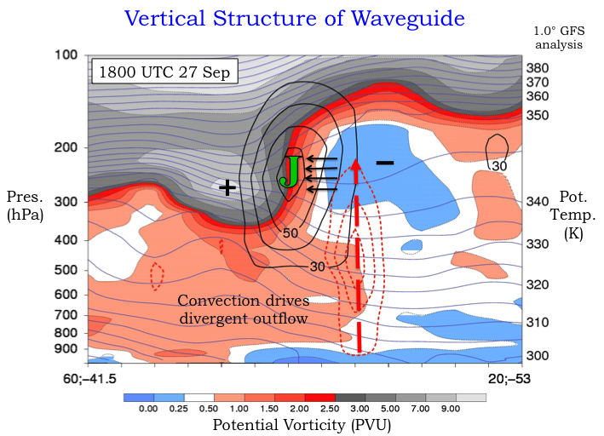

Figure 6. Cross section through the upper-level PV gradient and jet in Fig. 5.

A summary of the relationship between hypotheses, observations and deployment strategies appears in Table 2.

|  |  |  |  |  |
| --- | --- | --- | --- | --- |
| **Hypothesis** | **Required Observation(s)** | **Instrument(s)** | **Deployment** | **Supporting data** |
| 1. Divergent flow perturbs waveguide | Upper-tropospheric winds and PV | HCR, MTP and dropsondes; flight-level trace species (ozone and CO, to define mixing regions) | Maximum altitude; several flight legs normal to jet (PV) | Satellite cloud drift winds; operational analysis |
| 2. Predictability is limited by errors in vertical mass flux | Area-average profiles of vertical motion; microphysics, particle residuals | Dropsondes and HCR: obtain mass flux profiles; CVI | Flight tracks surrounding mesoscale precipitation regions | Ensemble data assimilation and sensitivity analysis |
| 3. Tropical plumes inject water vapor and other chemicals into lower stratosphere | Trace constituent measurements | VCSEL, TOGA, CARI instruments | Flight transects of jet; lower-altitude upstream samples | Trajectories from operational analysis products |
| 4. TPVs intensified through radiative processes | Radiative fluxes, water vapor profiles, clouds | Dropsondes, spectral upward and downward radiative flux, HCR | Flights in mid-upper troposphere, many over land; often prior to tropical plume development |  |
|  |  |  |  |  |
|  |  |  |  |  |
| Table 2. Science Traceability Matrix  **Not complete. Matrix needs more information** | | | | |

**5. Collaborations**

The science and field measurements of DOWNSTREAM can be conducted if there are no other facilities involved. However, DOWNSTREAM is part of the broader THORPEX-North Atlantic Waveguide and Downstream Impact Experiment (T-NAWDEX), which represents an international collaboration of Germany, U.K., France, Canada and the U.S. The objectives of T-NAWDEX follow from science objectives of the Predictability and Dynamical Processes working group of THORPEX. These can be succinctly stated studies to quantify: (a) the detailed PV-structure around the jet (b) warm conveyer belts (WCBs) and how they influence the near-tropopause PV evolution, and (c) how specific diabatically forced phenomena like diabatic Rossby waves develop and evolve. These science objectives mirror many elements of DOWNSTREAM. Indeed, the measurements proposed herein as part of DOWNSTREAM are crucial for achieving the broad goals of T-NAWDEX in addition to answering the scientific hypotheses raised in Sec. 3.

Figure 7. Summary of international deployment opportunity during September and October, 2016. Large black arrow represents the primary jet and downstream development direction. Green, red and blue arrows indicate polar, moisture plume and ET contributions to the waveguide perturbation, respectively.

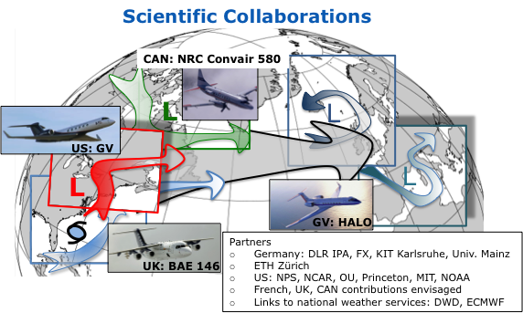

The international deployment of T-NAWDEX is depicted schematically in Fig. 7. From the perspective of DOWNSTREAM, the U.K. BAE 146 and the Canadian Convair would be well suited to perform the lower-altitude sampling of the moisture in convective regions, microphysics in mixed-phase regions, and water vapor and chemical measurements in the source regions for the moisture plumes. Both aircraft would be based on the western side of the Atlantic.

HALO would fly higher than the GV, generally in the range of 43,000-45,000 feet. Equipped with wind lidars, MTP, and trace constituent measurement capabilities (CO2, NOx, O3), HALO could be operated in a coordinated flight with the GV in which the two aircraft fly a stacked leg or legs normal to the jet. This would allow unprecedented sampling of both cloudy and clear regions near the jet.

HALO would be based in Oberpfaffenhofen, Germany, with a possible option of crossing the Atlantic. Generally, the aircraft would be expected to fly west to roughly 45W, and could monitor systems on days subsequent to their sampling by the GV. HALO could also monitor trace constituents in the lower stratosphere to the east of their observation by the GV in order to examine how the concentrations evolve in time.

**6. Data Analysis**

**Needs to be filled in**

a. Data Assimilation

b. Integration of fine-scale observations

**References**

**Please provide specific references**