Chapter 7: Objective Analysis (OBSGRID)

Table of Contents
- Introduction
- Program Flow
- Source of Observations
- Objective Analysis techniques in OBSGRID
- Quality Control for Observations
- Additional Observations
- Surface FDDA option
- Objective Analysis on Model Nests
- How to run OBSGRID
- Output Files
- Plot Utilities
- Observations Format
- OBSGRID Namelist

Introduction
The goal of objective analysis in meteorological modeling is to improve meteorological analyses (the first guess) on the mesoscale grid by incorporating information from observations. Traditionally, these observations have been "direct" observations of temperature, humidity, and wind from surface and radiosonde reports. As remote sensing techniques come of age, more and more "indirect" observations are available for researchers and operational modelers. Effective use of these indirect observations for objective analysis is not a trivial task. Methods commonly employed for indirect observations include three-dimensional or four-dimensional variational techniques ("3DVAR" and "4DVAR", respectively), which can be used for direct observations as well.
This chapter discusses the objective analysis program, OBSGRID. Discussion of variational techniques (WRFDA) can be found in Chapter 6 of this User’s Guide.
The analyses input to OBSGRID as the first guess are analyses output from the METGRID part of the WPS package (see Chapter 3 of this User’s Guide for details regarding the WPS package).

OBSGRID capabilities include:
- Choice of Cressman-style or Multiquadric objective analysis.
- Various tests to screen the data for suspect observations.
- Procedures to input bogus data.
- Expanded Grid: OBSGRID has the capability to cut the input model domain down on output. This feature allows you to incorporate data from outside your intended grid to improve analyses near the boundaries. To use this feature, a user must create a larger domain than the final intended domain when running WPS.

Program Flow
OBSGRID is run directly after metgrid.exe, and uses the met_em* output files from metgrid.exe as input. OBSGRID also requires additional observations (A) as input. The format of these observational files is described in the Observations Format section of this chapter.
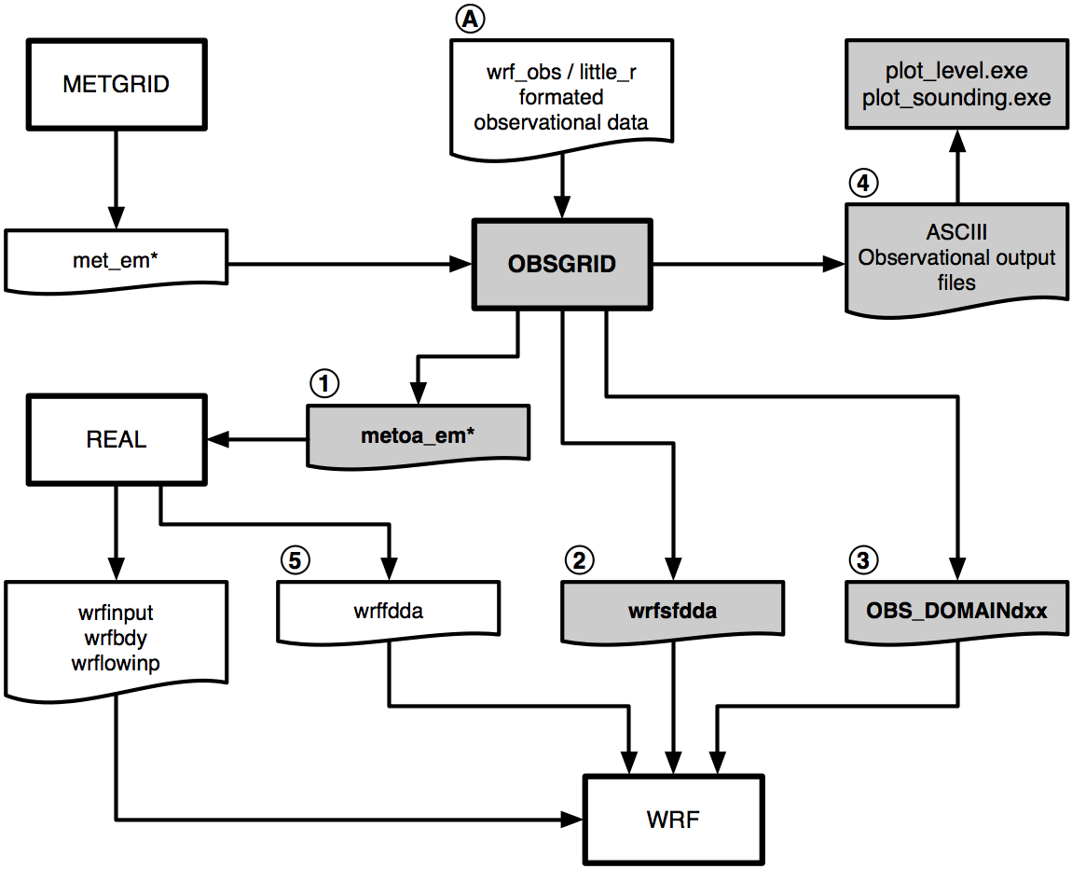
Output from the objective analysis programs can be used to:
- Provide fields for Initial and Boundary conditions (1). Note that the files metoa_em* are formatted identically to the met_em* files from metgrid.exe. The only difference is that the fields in these files now incorporate observational information.
- Provide surface fields for surface-analysis-nudging FDDA (2). Note, when using the wrfsfdda file as input to WRF, it is also recommended to use the 3-D fdda file (wrffdda (5) – which is an optional output created when running real.exe) as input to WRF.
- Provide data for observational nudging (3). Note: since version 3.1.1 of OBSGRID this file can be read directly by the observational nudging code and no longer needs to pass through an additional perl script.
- Provide ASCII output (4). These files provide information regarding the observations used and the quality control flags assigned. The information in these files can also be plotted with the provided plotting utilities.

Source of Observations
OBSGRID reads observations provided by the user in formatted ASCII text files. This allows users to adapt their own data to use as input to the OBSGRID program. This format (wrf_obs / little_r format) is the same format used in the MM5 objective analysis program LITTLE_R (hence the name).
Programs are available to convert NMC ON29 and NCEP BUFR formatted files (see below) into the wrf_obs / little_r format. Users are responsible for converting other observations they may want to provide to OBSGRID into this format. A user-contributed (i.e., unsupported) program is available in the utils/ directory for converting observation files from the GTS to wrf_obs / little_r format.
NCEP operational global surface and upper-air observation subsets, as archived by the Data Support Section (DSS) at NCAR.
- Upper-air data in NMC ON29 format (from early 1970s to early 2000 - http://dss.ucar.edu/datasets/ds353.4/)
- Surface data in NMC ON29 format (from early 1970s to early 2000 - http://dss.ucar.edu/datasets/ds464.0/)
- Upper-air data in NCEP BUFR format (from 1999 to present - http://dss.ucar.edu/datasets/ds351.0/)
- Surface data in NCEP BUFR format (from 1999 to present - http://dss.ucar.edu/datasets/ds461.0/)
NMC Office Note 29 can be found in many places on the World Wide Web, including:
http://www.emc.ncep.noaa.gov/mmb/data_processing/on29.htm

Objective Analysis techniques in OBSGRID

Cressman Scheme
Three of the four objective analysis techniques used in OBSGRID are based on the Cressman scheme, in which several successive scans nudge a first-guess field toward the neighboring observed values.
The standard Cressman scheme assigns to each observation a circular radius of influence, R. The first-guess field at each grid point, P, is adjusted by taking into account all the observations that influence P.
The differences between the first-guess field and the observations are calculated, and a distance-weighted average of these difference values is added to the value of the first-guess at P. Once all grid points have been adjusted, the adjusted field is used as the first guess for another adjustment cycle. Subsequent passes each use a smaller radius of influence.
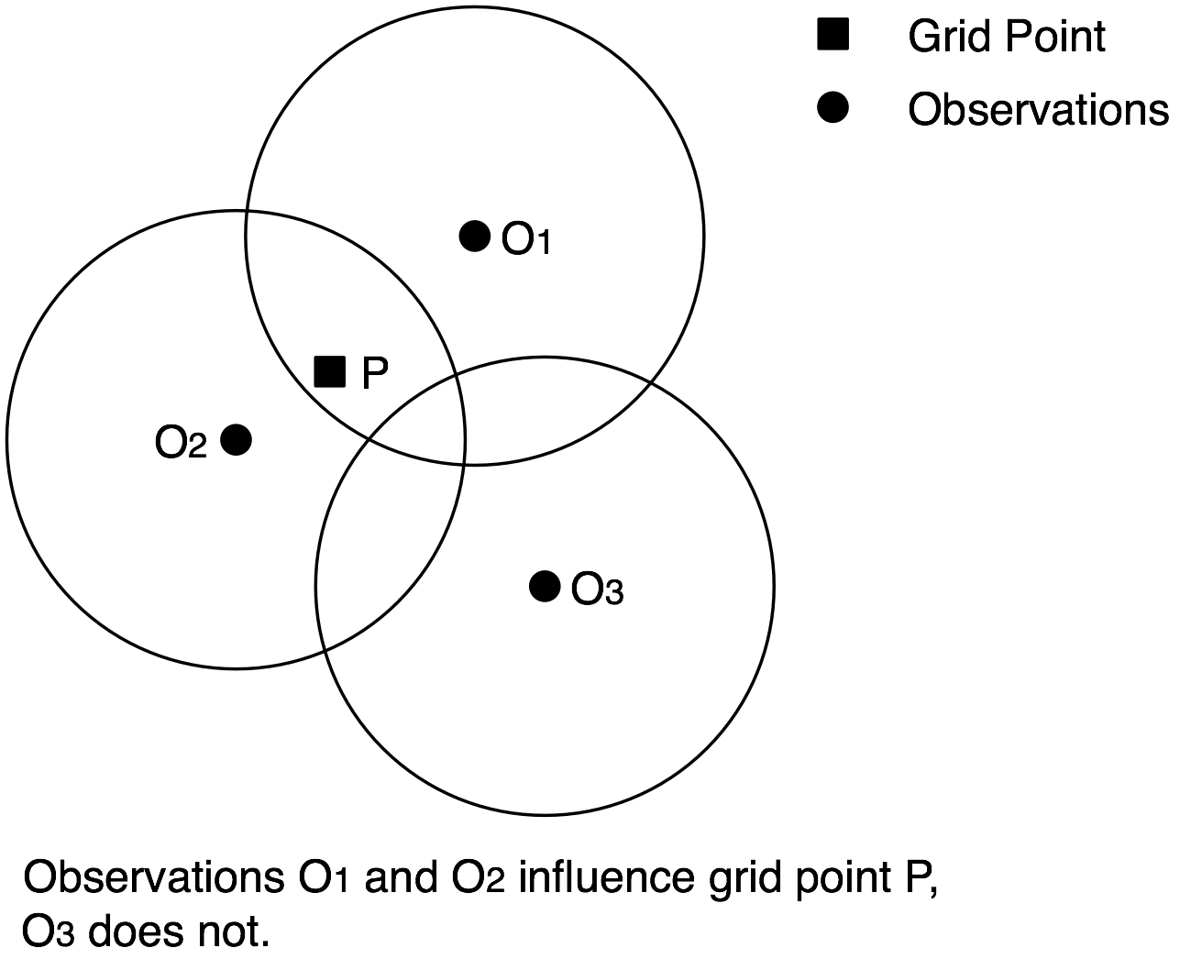

Ellipse Scheme
In analyses of wind and relative humidity (fields strongly deformed by the wind) at pressure levels, the circles from the standard Cressman scheme are elongated into ellipses, oriented along the flow. The stronger the wind, the greater the eccentricity of the ellipses. This scheme reduces to the circular Cressman scheme under low-wind conditions.

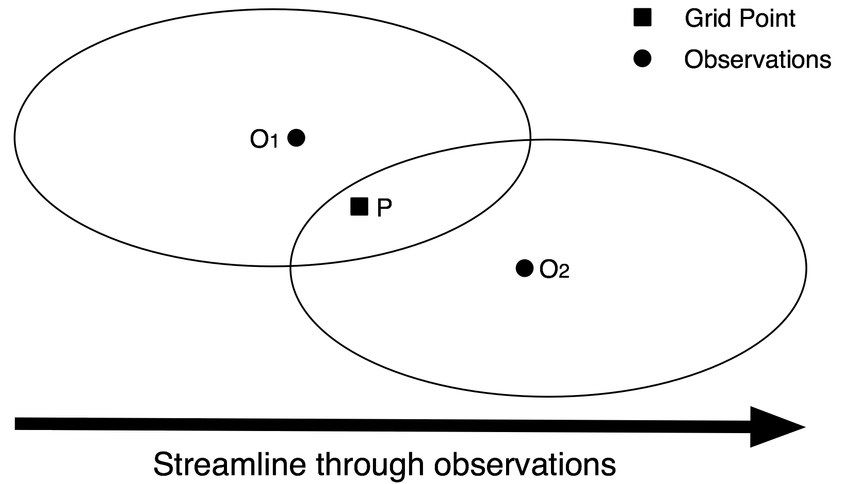

Banana Scheme
In analyses of wind and relative humidity at pressure levels, the circles from the standard Cressman scheme are elongated in the direction of the flow, and curved along the streamlines. The result is a banana shape. This scheme reduces to the Ellipse scheme under straight-flow conditions, and the standard Cressman scheme under low-wind conditions.

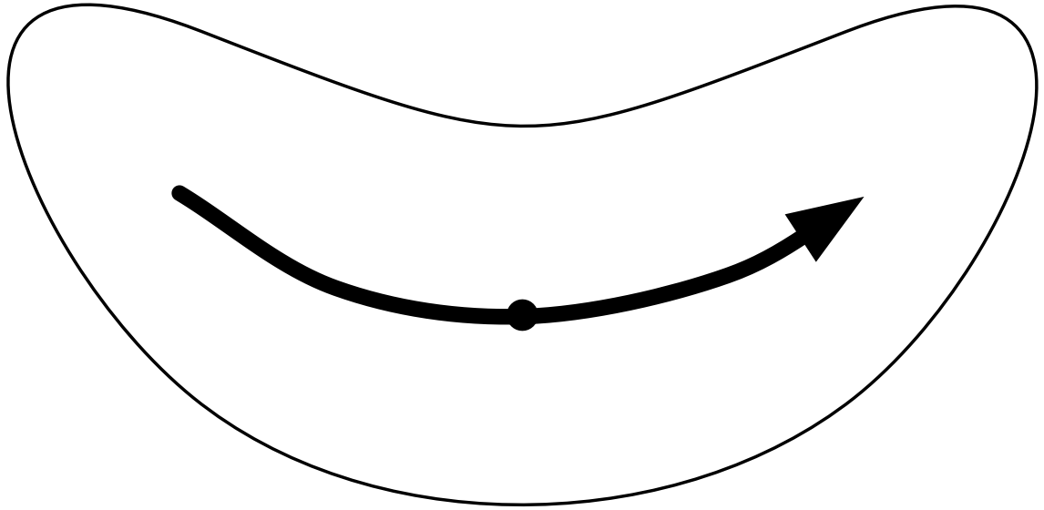

Multiquadric scheme
The Multiquadric scheme uses hyperboloid radial basis functions to perform the objective analysis. Details of the multiquadric technique may be found in Nuss and Titley, 1994: "Use of multiquadric interpolation for meteorological objective analysis." Mon . Wea . Rev ., 122, 1611-1631. Use this scheme with caution, as it can produce some odd results in areas where only a few observations are available.

Quality Control for Observations
A critical component of OBSGRID is the screening for bad observations. Many of these QC checks are optional in OBSGRID.

Quality Control on Individual Reports
- Gross Error Checks (same values, pressure decreases with height, etc.)
- Remove spikes from temperature and wind profiles.
- Adjust temperature profiles to remove superadiabatic layers.
- No comparisons to other reports or to the first-guess field.

The ERRMAX test
The ERRMAX quality-control check is optional, but highly recommended.
- Limited user control over data removal. The user may set thresholds, which vary the tolerance of the error check.
- Observations are compared to the first-guess field.
- If the difference value (obs - first-guess) exceeds a certain threshold, the observation is discarded.
- Threshold varies depending on the field, level, and time of day.
- Works well with a good first-guess field.

The Buddy test
The Buddy check is optional, but highly recommended.
- Limited user control over data removal. The user may set weighting factors, which vary the tolerance of the error check.
- Observations are compared to both the first guess and neighboring observations.
- If the difference value of an observation (obs - first-guess) varies significantly from the distance-weighted average of the difference values of neighboring observations, the observation is discarded.
- Works well in regions with good data density.

Additional Observations
Input of additional observations, or modification of existing (and erroneous) observations, can be a useful tool at the objective analysis stage.
In OBSGRID, additional observations are provided to the program the same way (in the same wrf_obs / little_r format) as standard observations. Additional observations must be in the same file as the rest of the observations. Existing (erroneous) observations can be modified easily, as the observations input format is ASCII text. Identifying an observation report as "bogus" simply means that it is assumed to be good data, but no quality control is performed for that report.

Surface FDDA option
The surface FDDA option creates additional analysis files for the surface only, usually with a smaller time interval between analyses (i.e., more frequently) than the full upper-air analyses. The purpose of these surface analysis files is for later use in WRF with the surface analysis nudging option.
The LAGTEM option controls how the first-guess field is created for surface analysis files. Typically, the surface and upper-air first-guess (analysis times) is available at twelve-hour or six-hour intervals, while the surface analysis interval may be 3 hours (10800 seconds). So at analysis times, the available surface first-guess is used. If LAGTEM is set to .FALSE., the surface first-guess at other times will be temporally interpolated from the first-guess at the analysis times. If LAGTEM is set to .TRUE., the surface first guess at other times is the objective analysis from the previous time.

Objective Analysis on Model Nests
OBSGRID has the capability to perform the objective analysis on a nest. This is done manually with a separate OBSGRID process, performed on met_em_d0x files for the particular nest. Often, however, such a step is unnecessary; it complicates matters for the user and may introduce errors into the forecast. At other times, extra information available to the user, or extra detail that objective analysis may provide on a nest, makes objective analysis on a nest a good option.
The main reason to do objective analysis on a nest is if you have observations available with horizontal resolution somewhat greater than the resolution of your coarse domain. There may also be circumstances in which the representation of terrain on a nest allows for better use of surface observations (i.e., the model terrain better matches the real terrain elevation of the observation).
The main problem introduced by doing objective analysis on a nest is inconsistency in initial conditions between the coarse domain and the nest. Observations that fall just outside a nest will be used in the analysis of the coarse domain, but discarded in the analysis of the nest. With different observations used right at a nest boundary, one can get very different analyses.

How to run OBSGRID

Get the source code
The source code can be downloaded from: http://www.mmm.ucar.edu/wrf/users/download/get_source.html. Once the tar file is gunzipped (gunzip OBSGRID.TAR.gz), and untared (untar OBSGRID.TAR), it will create an OBSGRID/ directory.
cd OBSGRID

Generate the executable
The only library that is required to build the WRF model is NetCDF. The user can find the source code, precompiled binaries, and documentation at the UNIDATA home page (http://www.unidata.ucar.edu/software/netcdf/ ).
To successfully compile the utilities plot_level.exe and plot_sounding.exe, NCAR Graphics needs to be installed on your system. These routines are not necessary to run OBSGRID, but are useful for displaying observations.
To configure, type:
./configure
Choose one of the configure options, then compile.
./compile
If successful, this will create the executable obsgrid.exe. Executables plot_level.exe and plot_sounding.exe, will be created if NCAR Graphics is installed.

Prepare the observations files
Preparing observational files is a user responsibility. Some data are available from NCAR’s DSS web site. Data from the early 1970’s are in ON29 format, while data from 1999 to present are in NCEP BUFR format. Conversion programs for the NCEP BUFR data are also available from the DSS web site. For the upper-air data the converter (BUFRdecode_ADPuprair_littlr.tar) is available at: http://dss.ucar.edu/datasets/ds351.0/software/, and the surface convert (BUFRdecode_ADPsfc_littlr.tar) is posted at http://dss.ucar.edu/datasets/ds461.0/software/.
A program is available for users with access to NCAR's Bluefire computers to download archived observations and reformat them into the wrf_obs/little_r format. This can be found in the directory ~wrfhelp/BATCH, and the program is called FETCH_obs_data.tar.gz.
A program is also available for reformatting observations from the GTS stream (unsupported). This can be found in OBSGRID/util, and is called gts_cleaner.f.
The code expects to find one observational input file per analysis time. Each file should contain both surface and upper-air data (if available).

Edit the namelist for your specific case
The most critical information you'll be changing most often is the start date, end date, and file names.
Pay particularly careful attention to the file name settings. Mistakes in observation file names can go unnoticed because OBSGRID will happily process the wrong files, and if there are no data in the (wrongly-specified) file for a particular time, OBSGRID will happily provide you with an analysis of no observations.

Run the program
Run the program by invoking the command:
./obsgrid.exe >& obsgrid.out
Check the obsgrid.out file for information and runtime errors.

Check your output
Examine the obsgrid.out file for error messages or warning messages. The program should have created the files called metoa_em*. Additional output files containing information about observations found, used and discarded will probably be created, as well.
Important things to check include the number of observations found for your objective analysis, and the number of observations used at various levels. This can alert you to possible problems in specifying observation files or time intervals. This information is included in the printout file.
You may also want to experiment with a couple of simple plot utility programs, discussed below.
There are a number of additional output files, which you might find useful. These are discussed below.

Output Files
The OBSGRID program generates some ASCII text files to detail the actions taken on observations through a time cycle of the program. In support of users wishing to plot the observations used for each variable (at each level, at each time), a file is created with this information. Primarily, the ASCII text files are for consumption by the developers for diagnostic purposes. The main output of the OBSGRID program is the gridded, pressure-level data set to be passed to the real.exe program (files metoa_em*).
In each of the files listed below, the text ".dn.YYYY-MM-DD_HH:mm:ss.tttt" allows each time period that is processed by OBSGRID to output a separate file. The only unusual information in the date string is the final four letters "tttt" which is the decimal time to ten thousandths of a second. These files will be dependant on the domain being processed.

metoa_em*
These are the final analysis files at surface and pressure levels. Generating this file is the primary goal of running OBSGRID.
These files can now be used in place of the met_em* files from WPS to generate initial and boundary conditions for WRF. To use these files when running real.exe you can do one of two things:
- Rename or link the metoa_em* files back to met_em*. This way real.exe will read the files automatically.
- Use the auxinput1_inname namelist option in WRF’s namelist.input file to overwrite the default filename real.exe uses. To do this, add the following to the &time_control section of the WRF namelist.input file before running real.exe (use the exact syntax as below – do not substitute the <domain> and <date> for actual numbers):
auxinput1_inname = "metoa_em.d<domain>.<date>"

wrfsfdda_dn
Use of the surface FDDA option in OBSGRID creates a file called wrfsfdda_dn. This file contains the surface analyses at INTF4D intervals, analyses of T, TH, U, V, RH, QV, PSFC, PMSL, and a count of observations within 250 km of each grid point.
Due to the input requirements of the WRF model, data at the current time (_OLD) and data for the next time (_NEW) are supplied at each time interval. Due to this requirement, users must take care to specify the same interval in the WRF fdda section for surface nudging as the interval used in OBSGRID to create the wrfsfdda_dn file.

OBS_DOMAINdxx
These files can be used in WRF for observational nudging. The format of this file is slightly different from the standard wrf_obs / little_r format. See Chapter 5 of this User’s Guide for details on observational nudging.
The “d” in the file name represents the domain number. The “xx” is just a sequential number.
These files contain a list of all of the observations available for use by the OBSGRID program.
- The observations have been sorted and the duplicates have been removed.
- Observations outside of the analysis region have been removed.
- Observations with no information have been removed.
- All reports for each separate location (different levels, but at the same time) have been combined to form a single report.
- Data which has had the "discard" flag internally set (data which will not be sent to the quality control or objective analysis portions of the code) are not listed in this output.
- The data have gone through an expensive test to determine if the report is within the analysis region, and the data have been given various quality control flags. Unless a blatant error in the data is detected (such as a negative sea-level pressure), the observation data are not typically modified, but only assigned quality control flags.
- Data with qc flags higher than a specified value (user controlled, via the namelist), will be set to missing data.
The WRF observational nudging code requires that all observational data are available in a single file called OBS_DOMAINd01 (where d is the domain number), whereas OBSGRID creates one file per time. Therefore, to use these files in WRF, they should first be concatenated to a single file. A script (run_cat_obs_files.csh) is provided for this purpose. By running this script, the original OBS_DOMAINd01 files will be moved to OBS_DOMAINd01_sav, and a new OBS_DOMAINd01 file (containing all the observations for all times) will be created. This new file can be used directly in the WRF observational nudging code.

qc_obs_raw.dn.YYYY-MM-DD_HH:mm:ss.tttt
This file contains a listing of all of the observations available for use by the OBSGRID program.
- The observations have been sorted and the duplicates have been removed.
- Observations outside of the analysis region have been removed.
- Observations with no information have been removed.
- All reports for each separate location (different levels, but at the same time) have been combined to form a single report.
- Data which has had the "discard" flag internally set (data which will not be sent to the quality control or objective analysis portions of the code) are not listed in this output.
- The data have gone through an expensive test to determine if the report is within the analysis region, and the data have been given various quality control flags. Unless a blatant error in the data is detected (such as a negative sea-level pressure), the observation data are not typically modified, but only assigned quality control flags.
- This data can be used as input to the plotting utility plot_sounding.exe

qc_obs_used.dn.YYYY-MM-DD_HH:mm:ss.tttt
This file contains exactly the same data as in the OBS_DOMAINdxx file, but in this case the format is standard wrf_obs/little_r data format.

plotobs_out.dn.YYYY-MM-DD_HH:mm:ss.tttt
This file lists data by variable and by level, where each observation that has gone into the objective analysis is grouped with all of the associated observations for plotting or some other diagnostic purpose. The first line of this file is the necessary FORTRAN format required to input the data. There are titles over the data columns to aid in the information identification. Below are a few lines from a typical file. This data can be used as input to the plotting utility plot_level.exe
( 3x,a8,3x,i6,3x,i5,3x,a8,3x,2(g13.6,3x),2(f7.2,3x),i7 )
Number of Observations 00001214
Variable Press Obs Station Obs Obs-1st X Y QC
Name Level Number ID Value Guess Location Location Value
U 1001 1 CYYT 6.39806 4.67690 161.51 122.96 0
U 1001 2 CWRA 2.04794 0.891641 162.04 120.03 0
U 1001 3 CWVA 1.30433 -1.80660 159.54 125.52 0
U 1001 4 CWAR 1.20569 1.07567 159.53 121.07 0
U 1001 5 CYQX 0.470500 -2.10306 156.58 125.17 0
U 1001 6 CWDO 0.789376 -3.03728 155.34 127.02 0
U 1001 7 CWDS 0.846182 2.14755 157.37 118.95 0

Plot Utilities
The OBSGRID package provides two utility programs for plotting observations. These programs are called plot_soundings.exe and plot_levels.exe. These optional programs use NCAR Graphics, and are built. Both programs get additional input options from the namelist.oa file.

plot_soundings.exe
Program plot_soundings.exe plots soundings. This program generates soundings from the qc_obs_raw.dn.YYYY-MM-DD_HH:mm:ss.tttt and qc_obs_used.dn.YYYY-MM-DD_HH:mm:ss.tttt data files. Only data that are on the requested analysis levels are processed.
The program uses information from &record1, &record2 and &plot_souding in the namelist.oa file to generate the required output.
The program creates output file(s): sounding_<file_type>_<date>.cgm

plot_level.exe
Program plot_level.exe creates station plots for each analysis level. These plots contain both observations that have passed all QC tests and observations that have failed the QC tests. Observations that have failed the QC tests are plotted in various colors according to which test failed.
The program uses information from &record1 and &record2 in the namelist.oa file to generate plots from the observations in the file plotobs_out.dn.YYYY-MM-DD_HH:mm:ss.tttt.
The program creates the file(s): levels_<date>.cgm or levels_sfc_fdda_<date>.cgm, depending on which file type is plotted.

Observations Format
To make the best use of the OBSGRID program, it is important for users to understand the wrf_obs/little_r Observations Format.
Observations are conceptually organized in terms of reports. A report consists of a single observation or set of observations associated with a single latitude/longitude coordinate.
Examples
- a surface station report including observations of temperature, pressure, humidity, and winds.
- an upper-air station's sounding report with temperature, humidity, and wind observations at many height or pressure levels.
- an aircraft report of temperature at a specific lat/lon/height.
- a satellite-derived wind observation at a specific lat/lon/height.
Each report in the wrf_obs/little_r Observations Format consists of at least four records:
- A report header record
- one or more data records
- an end data record
- an end report record .
The report header record is a 600-character-long record (much of which is unused and needs only dummy values) that contains certain information about the station and the report as a whole (location, station id, station type, station elevation, etc.). The report header record is described fully in the following table. Shaded items in the table are unused:
Report header format
Variable | Fortran I/O Format | Description
latitude | F20.5 | station latitude (north positive)
longitude | F20.5 | station longitude (east positive)
id | A40 | ID of station
name | A40 | Name of station
platform | A40 | Description of the measurement device
source | A40 | GTS, NCAR/ADP, BOGUS, etc.
elevation | F20.5 | station elevation (m)
num_vld_fld | I10 | Number of valid fields in the report
num_error | I10 | Number of errors encountered during the decoding of this observation
num_warning | I10 | Number of warnings encountered during decoding of this observation.
seq_num | I10 | Sequence number of this observation
num_dups | I10 | Number of duplicates found for this observation
is_sound | L10 | T/F Multiple levels or a single level
bogus | L10 | T/F bogus report or normal one
discard | L10 | T/F Duplicate and discarded (or merged) report.
sut | I10 | Seconds since 0000 UTC 1 January 1970
julian | I10 | Day of the year
date_char | A20 | YYYYMMDDHHmmss
slp, qc | F13.5, I7 | Sea-level pressure (Pa) and a QC flag
ref_pres, qc | F13.5, I7 | Reference pressure level (for thickness) (Pa) and a QC flag
ground_t, qc | F13.5, I7 | Ground Temperature (T) and QC flag
sst, qc | F13.5, I7 | Sea-Surface Temperature (K) and QC
psfc, qc | F13.5, I7 | Surface pressure (Pa) and QC
precip, qc | F13.5, I7 | Precipitation Accumulation and QC
t_max, qc | F13.5, I7 | Daily maximum T (K) and QC
t_min, qc | F13.5, I7 | Daily minimum T (K) and QC
t_min_night, qc | F13.5, I7 | Overnight minimum T (K) and QC
p_tend03, qc | F13.5, I7 | 3-hour pressure change (Pa) and QC
p_tend24, qc | F13.5, I7 | 24-hour pressure change (Pa) and QC
cloud_cvr, qc | F13.5, I7 | Total cloud cover (oktas) and QC
ceiling, qc | F13.5, I7 | Height (m) of cloud base and QC
Following the report header record are the data records. These data records contain the observations of pressure, height, temperature, dewpoint, wind speed, and wind direction. There are a number of other fields in the data record that are not used on input. Each data record contains data for a single level of the report. For report types that have multiple levels (e.g., upper-air station sounding reports), each pressure or height level has its own data record. For report types with a single level (such as surface station reports or a satellite wind observation), the report will have a single data record. The data record contents and format are summarized in the following table
Format of data records
Variable | Fortran I/O Format | Description
pressure, qc | F13.5, I7 | Pressure (Pa) of observation, and QC
height, qc | F13.5, I7 | Height (m MSL) of observation, and QC
temperature, qc | F13.5, I7 | Temperature (K) and QC
dew_point, qc | F13.5, I7 | Dewpoint (K) and QC
speed, qc | F13.5, I7 | Wind speed (m/s) and QC
direction, qc | F13.5, I7 | Wind direction (degrees) and QC
u, qc | F13.5, I7 | u component of wind (m/s), and QC
v, qc | F13.5, I7 | v component of wind (m/s), and QC
rh, qc | F13.5, I7 | Relative Humidity (%) and QC
thickness, qc | F13.5, I7 | Thickness (m), and QC
The end data record is simply a data record with pressure and height fields both set to -777777.
After all the data records and the end data record, an end report record must appear. The end report record is simply three integers, which really aren't all that important.

Format of end_report records
Variable | Fortran I/O Format | Description
num_vld_fld | I7 | Number of valid fields in the report
num_error | I7 | Number of errors encountered during the decoding of the report
num_warning | I7 | Number of warnings encountered during the decoding the report

QCFlags
In the observation files, most of the meteorological data fields also have space for an additional integer quality-control flag. The quality-control values are of the form 2n, where n takes on positive integer values. This allows the various quality control flags to be additive, yet permits the decomposition of the total sum into constituent components. Following are the current quality control flags that are applied to observations:
pressure interpolated from first-guess height = 2 ** 1 = 2
temperature and dew point both = 0 = 2 ** 4 = 16
wind speed and direction both = 0 = 2 ** 5 = 32
wind speed negative = 2 ** 6 = 64
wind direction < 0 or > 360 = 2 ** 7 = 128
level vertically interpolated = 2 ** 8 = 256
value vertically extrapolated from single level = 2 ** 9 = 512
sign of temperature reversed = 2 ** 10 = 1024
superadiabatic level detected = 2 ** 11 = 2048
vertical spike in wind speed or direction = 2 ** 12 = 4096
convective adjustment applied to temperature field = 2 ** 13 = 8192
no neighboring observations for buddy check = 2 ** 14 = 16384
----------------------------------------------------------------------
data outside normal analysis time and not QC-ed = 2 ** 15 = 32768
----------------------------------------------------------------------
fails error maximum test = 2 ** 16 = 65536
fails buddy test = 2 ** 17 = 131072
observation outside of domain detected by QC = 2 ** 18 = 262144

OBSGRID Namelist
The OBSGRID namelist file is called "namelist.oa", and must be in the directory from which OBSGRID is run. The namelist consists of nine namelist records, named "record1" through "record9", each having a loosely related area of content. Each namelist record, which extends over several lines in the namelist.oa file, begins with "&record<#>" (where <#> is the namelist record number) and ends with a slash "/".
The namelist record &plot_sounding is only used by the corresponding utility.

Namelist record1
The data in namelist record1 define the analysis times to process:
Namelist Variable | Value | Description
start_year | 2000 | 4-digit year of the starting time to process
start_month | 01 | 2-digit month of the starting time to process
start_day | 24 | 2-digit day of the starting time to process
start_hour | 12 | 2-digit hour of the starting time to process
end_year | 2000 | 4-digit year of the ending time to process
end_month | 01 | 2-digit month of the ending time to process
end_day | 25 | 2-digit day of the ending time to process
end_hour | 12 | 2-digit hour of the ending time to process
interval | 21600 | Time interval (s) between consecutive times to process

Namelist record2
The data in record2 define the model grid and names of the input files:
Namelist Variable | Value | Description
domain_id | 1 | ID of domain to process
obs_filename | CHARACTER | Root file name (may include directory information) of the observational files. All input files must have the format obs_filename:<YYYY-MM-DD_HH>.  One file required for each time period.  If a wrfsfdda is being created, then similar input data files are required for each surface fdda time.
remove_data_above_qc_flag | 200000 | Data with qc flags higher than this will not be output to the OBS_DOMAINdxx files. Default is to output all data. Use 65536 to remove data that failed the buddy and error max tests. To also exclude data outside analysis times that could not be QC-ed use 32768 (recommended).  This does not affect the data used in the OA process.
remove_unverified_data | .FALSE. | When input data is not on an analysis level, the data cannot be QC-ed. This data is never used in the OA process, but may make its way into the ASCII output files. By setting this parameter to .TRUE. (recommended) these observations will be removed from the OBS_DOMAINdxx files.
trim_domain | .FALSE. | Set to .TRUE. if this domain must be cut down on output
trim_value | 5 | Value by which the domain will be cut down in each direction
The met_em* files which are being processed must be available in the OBSGRID/ directory.
The obs_filename and interval settings can get confusing, and deserve some additional explanation. Use of the obs_filename files is related to the times and time interval set in namelist &record1, and to the F4D options set in namelist &record8. The obs_filename files are used for the analyses of the full 3D dataset, both at upper levels and the surface. They are also used when F4D=.TRUE.; that is, if surface analyses are being created for surface FDDA nudging. The obs_filename files should contain all observations (upper-air and surface) to be used for a particular analysis at a particular time.
Ideally there should be an obs_filename for each time period for which an objective analysis is desired. Time periods are processed sequentially from the starting date to the ending date by the time interval, all specified in namelist &record1. All observational files must have a date associated with them. If a file is not found, the code will process as if this file contains zero observations, and then continue to the next time period.
If the F4D option is selected, the obs_filename files are similarly processed for surface analyses, this time with the time interval as specified by INTF4D.
If a user wishes to include observations from outside the model domain of interest, geogrid.exe (WPS) needs to be run over a slightly larger domain than the domain of interest. Setting trim_domain to .TRUE. will cut all 4 directions of the input domain down by the number of grid points set in trim_value.
In the example below, the domain of interest is the inner white domain with a total of 100x100 grid points. geogrid.exe has been run for the outer domain (110x110 grid points). By setting the trim_value to 5, the output domain will be trimmed by 5 grid points in each direction, resulting in the white 100x100 grid point domain.
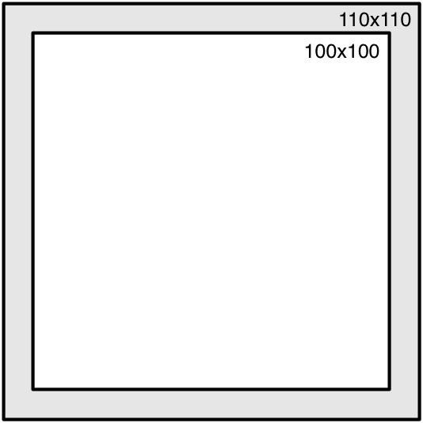

Namelist record3
The data in the &record3 concern space allocated within the program for observations. These are values that should not frequently need to be modified:
Namelist Variable | Value | Description
max_number_of_obs | 10000 | Anticipated maximum number of reports per time period
fatal_if_exceed_max_obs | .TRUE. | T/F flag allows the user to decide the severity of not having enough space to store all of the available observation

Namelist record4
The data in &record4 set the quality control options. There are four specific tests that may be activated by the user: An error max test; a buddy test; removal of spike, and; the removal of super-adiabatic lapse rates. For some of these tests, a user has control over the tolerances, as well.
Namelist Variable | Value | Description
Error Max Test: For this test there is a threshold for each variable. These values are scaled for time of day, surface characteristics and vertical level.
qc_test_error_max | .TRUE. | Check the difference between the first-guess and the observation
max_error_t | 10 | Maximum allowable temperature difference (K)
max_error_uv | 13 | Maximum allowable horizontal wind component difference (m/s)
max_error_z | 8 | Not used
max_error_rh | 50 | Maximum allowable relative humidity difference (%)
max_error_p | 600 | Maximum allowable sea-level pressure difference (Pa
Buddy Check Test: For this test there is a threshold for each variable. These values are similar to standard deviations.
qc_test_buddy | .TRUE. | Check the difference between a single observation and neighboring observations
max_buddy_t | 8 | Maximum allowable temperature difference (K)
max_buddy_uv | 8 | Maximum allowable horizontal wind component difference (m/s)
max_buddy_z | 8 | Not used
max_buddy_rh | 40 | Maximum allowable relative humidity difference (%)
max_buddy_p | 800 | Maximum allowable sea-level pressure difference (Pa)
buddy_weight | 1.0 | Value by which the buddy thresholds are scale
Spike removal
qc_test_vert_consistency | .FALSE. | Check for vertical spikes in temperature, dew point, wind speed and wind direction
Removal of super-adiabatic lapse rates
qc_test_convective_adj | .FALSE. | Remove any super-adiabatic lapse rate in a sounding by conservation of dry static energy
For satellite and aircraft observations, data are often horizontally spaced with only a single vertical level. The following two entries describe how far the user assumes that the data are valid in pressure space.
max_p_extend_t | 1300 | Pressure difference (Pa) through which a single temperature report may be extended
max_p_extend_w | 1300 | Pressure difference (Pa) through which a single wind report may be extended

Namelist record5
The data in &record5 control the enormous amount of printout that may be produced by the OBSGRID program. These values are all logical flags, where TRUE will generate output and FALSE will turn off output.
print_obs_files ; print_found_obs ; print_header ; print_analysis ;print_qc_vert ; print_qc_dry ; print_error_max ; print_buddy ;print_oa

Namelist record7
The data in &record7 concern the use of the first-guess fields and surface FDDA analysis options. Always use the first guess.
Namelist Variable | Value | Description
use_first_guess | .TRUE. | Always use first guess (use_first_guess=.TRUE.)
f4d | .TRUE. | Turns on (.TRUE.) or off (.FALSE.) the creation of surface analysis files.
intf4d | 10800 | Time interval in seconds between surface analysis times
lagtem | .FALSE. | Use the previous time-period's final surface analysis for this time-period's first guess (lagtem=.TRUE.); or  Use a temporal interpolation between upper-air times as the first guess for this surface analysis (lagtem = .FALSE.)

Namelist record8
The data in &record8 concern the smoothing of the data after the objective analysis. Note, only the the differences fields (observation minus first-guess) of the analyzed are smoothed, not the full fields.
Namelist Variable | Value | Description
smooth_type | 1 | 1 = five point stencil of 1-2-1 smoothing; 2 = smoother-desmoother
smooth_sfc_wind | 0 | Number of smoothing passes for surface winds
smooth_sfc_temp | 0 | Number of smoothing passes for surface temperature
smooth_sfc_rh | 0 | Number of smoothing passes for surface relative humidity
smooth_sfc_slp | 0 | Number of smoothing passes for sea-level pressure
smooth_upper_wind | 0 | Number of smoothing passes for upper-air winds
smooth_upper_temp | 0 | Number of smoothing passes for upper-air temperature
smooth_upper_rh | 0 | Number of smoothing passes for upper-air relative humidity

Namelist record9
The data in &record9 concern the objective analysis options. There is no user control to select the various Cressman extensions for the radius of influence (circular, elliptical or banana). If the Cressman option is selected, ellipse or banana extensions will be applied as the wind conditions warrant.

Namelist Variable | Value | Description
oa_type | “Cressman” | “MQD” for multiquadric; “Cressman” for the Cressman-type scheme, this string is case sensitive
oa_3D_type | “Cressman” | Set upper-air scheme to “Cressman”, regardless of the scheme used at the surface
oa_3D_option | 0 | How to switch between “MQD” and “Cressman” if not enough observations are available to perform “MQD”
mqd_minimum_num_obs | 30 | Minimum number of observations for MQD
mqd_maximum_num_obs | 1000 | Maximum number of observations for MQD
radius_influence | 5,4,3,2 | Radius of influence in grid units for Cressman scheme
oa_min_switch | .TRUE. | T = switch to Cressman if too few observations for MQD; F = no analysis if too few observations
oa_max_switch | .TRUE. | T = switch to Cressman if too many observations for MQD; F = no analysis if too many observation

When oa_type is set to Cressman, then the Cressman scheme will be performed on all data.

When oa_type is set to MQD, there are a wide variety of options available that control when the code will revert back to the Cressman scheme.

oa_max_switch ; mqd_maximum_num_obs
The code will revert back to Cressman if the switch is set to true and the maximum number of observations is exceeded.
This is to reduce the time the code runs and not for physical reasons.
Recommended to leave switch set to true and just set the maximum number large.

oa_min_switch ; mqd_minimum_num_obs
The code will revert back to Cressman if the switch is set to true and there are too few observations. How and when the code reverts back to Cressman under these conditions are controlled by the oa_3D_option parameter.
Recommended to leave switch set to true and start with the default minimum settings.

oa_3D_type=”Cressman”
All upper-air levels will use the Cressman scheme, regardless of other settings.
The surface will use MQD as long as there are enough observations to do so (mqd_maximum_num_obs ; mqd_minimum_num_obs), otherwise it will revert to the Cressman scheme.
Note that if some time periods have enough observations and others do not, the code will only revert to Cressman for the times without sufficient observations.

oa_3D_option
There are three options (0,1,2). For all these options the surface will use MQD as long as there are enough observations to do so (mqd_maximum_num_obs ; mqd_minimum_num_obs), otherwise it will revert to the Cressman scheme.
Note that if some time periods have enough observations and others do not, the code will only revert to Cressman for the times without sufficient observations.
The upper-air will react as follows:
0 (default): MQD is performed in the upper-air as long as there are enough observations to do so (mqd_maximum_num_obs ; mqd_minimum_num_obs). As soon as this is no longer the case, the code will STOP, with suggestions as to which parameters to set to run the code correctly.
1: The code will first check to see if, for a given time, all levels and variables in the upper-air have sufficient observations for the MQD scheme. If not, the code will revert to Cressman for that time period. Note that if some time periods have enough observations and others do not, the code will only revert to Cressman for the times without sufficient observations.
2: The code will check if sufficient observations are available per time, level, and variable for the MQD scheme. If not, the code will revert to the Cressman scheme for that particular time, level and variable. Note this can result in uncontrolled switching between MQD and Cressman. Therefore this option is not recommended.
radius_influence
There are three ways to set the radius of influence (RIN) for the Cressman scheme:
- Manually: Set the RIN and number of scans directly. E.g., 5,4,3,2, will result in 4 scans. The first will use 5 grid points for the RIN and the last, 2 points.
- Automatically 1: Set RIN to 0 and the code will calculate the RIN based on the domain size and an estimated observation density of 325 km. By default there will be 4 scans.
- Automatically 2: Set RIN to a negative number and the code will calculate the RIN based on the domain size and an estimated observation density of 325 km. The number of scans is controlled by the value of the set number. E.g, -5 will result in 5 scans.

Namelist plot_sounding
Only used for the utility plot_sounding.exe
Namelist Variable | Value | Description
file_type | “raw” | File to read to produce the plots. Options are “raw” or “used”
read_metoa | .TRUE. | If set to .TRUE., the model domain information in the metoa_em files will be used to add location information on the plot.

