Chapter 1: Overview

Table of Contents
- Introduction
- The WRF ARW Modeling System Program Components

Introduction
The Advanced Research WRF (ARW) modeling system has been in development for the past few years. The current release is Version 3, available since April 2008. The ARW is designed to be a flexible, state-of-the-art atmospheric simulation system that is portable and efficient on available parallel computing platforms. The ARW is suitable for use in a broad range of applications across scales ranging from meters to thousands of kilometers, including:
- Idealized simulations (e.g. LES, convection, baroclinic waves)
- Parameterization research
- Data assimilation research
- Forecast research
- Real-time NWP
- Hurricane research
- Regional climate research
- Coupled-model applications
- Teaching
The Mesoscale and Microscale Meteorology Division of NCAR is currently maintaining and supporting a subset of the overall WRF code (Version 3) that includes:
- WRF Software Framework (WSF)
- Advanced Research WRF (ARW) dynamic solver, including one-way, two-way nesting and moving nest.
- The WRF Preprocessing System (WPS)
- WRF Data Assimilation (WRF-DA) system which currently supports 3DVAR 4DVAR, and hybrid data assimilation capabilities
- Numerous physics packages contributed by WRF partners and the research community
- Several graphics programs and conversion programs for other graphics tools
And these are the subjects of this document.
The WRF modeling system software is in the public domain and is freely available for community use.

The WRF Modeling System Program Components
The following figure shows the flowchart for the WRF Modeling System Version 3.
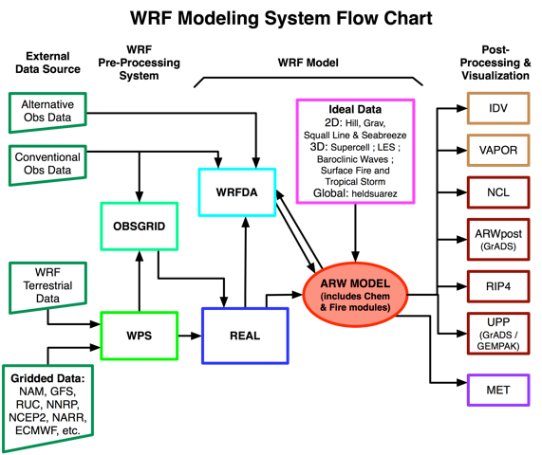
As shown in the diagram, the WRF Modeling System consists of these major programs:
- The WRF Preprocessing System (WPS)
- WRF-DA
- ARW solver
- Post-processing & Visualization tools

WPS
This program is used primarily for real-data simulations. Its functions include 1) defining simulation domains; 2) interpolating terrestrial data (such as terrain, landuse, and soil types) to the simulation domain; and 3) degribbing and interpolating meteorological data from another model to this simulation domain. Its main features include:
- GRIB 1/2 meteorological data from various centers around the world
- USGS 24 category and MODIS 20 category land datasets; USGS GTOPO30 elevation dataset; Global 5-minutes United Nation FAO, and North-America STATSGO 30 sec soil category dataset; 10-min greenness fraction data based on AVHRR and 30-sec greenness fraction data based on 10 years MODIS; MODIS-based leaf-area index; 0.15 degree monthly albedo and snow albedo data; and 1-degree deep soil temperature data; plus a few specialized datasets
- Map projections for 1) polar stereographic, 2) Lambert-Conformal, 3) Mercator and 4) latitude-longitude
- Nesting
- User-interfaces to input other static data as well as met data

WRF-DA
This program is optional, but can be used to ingest observations into the interpolated analyses created by WPS. It can also be used to update WRF model's initial conditions when the WRF model is run in cycling mode. Its main features are as follows:
- It is based on an incremental variational data assimilation technique, and has both 3D-Var and 4D-Var capabilities
- It also includes the capability of hybrid data assimilation (Variational + Ensemble)
- The conjugate gradient method is utilized to minimize the cost function in the analysis control variable space
- Analysis is performed on an un-staggered Arakawa A-grid
- Analysis increments are interpolated to staggered Arakawa C-grid and it gets added to the background (first guess) to get the final analysis of the WRF-model grid
- Conventional observation data input may be supplied either in ASCII format via the “obsproc” utility or “PREPBUFR” format.
- Multiple satellite observation data input may be supplied in BUFR format
- Multiple radar data (reflectivity & radial velocity) input is supplied through ASCII format
- Multiple outer loop to address the nonlinearity
- Capability to compute adjoint sensitivity
- Horizontal component of the background (first guess) error is represented via a recursive filter (for regional) or power spectrum (for global). The vertical component is applied through projections on climatologically generated averaged eigenvectors and its corresponding Eigen values
- Horizontal and vertical background errors are non-separable. Each eigenvector has its own horizontal climatologically-determined length scale
- Preconditioning of the background part of the cost function is done via the control variable transform U defined as B= UU^{T}
- It includes the “gen_be” utility to generate the climatological background error covariance estimate via the NMC-method or ensemble perturbations
- A utility program to update WRF boundary condition file after WRF-DA

ARW Solver
This is the key component of the modeling system, which is composed of several initialization programs for idealized, and real-data simulations, and the numerical integration program. The key features of the WRF model include:
- Fully compressible nonhydrostatic equations with hydrostatic option
- Regional and global applications
- Complete Coriolis and curvature terms
- Two-way nesting with multiple nests and nest levels
- Concurrent one-way nesting with multiple nests and nest levels
- Offline one-way nesting with vertical nesting
- Moving nests (prescribed moves and vortex tracking)
- Mass-based terrain-following coordinate
- Vertical grid-spacing can vary with height
- Map-scale factors for these projections:
  - polar stereographic (conformal)
  - Lambert-conformal
  - Mercator (conformal)
  - Latitude and longitude, which can be rotated
- Arakawa C-grid staggering
- Runge-Kutta 2nd and 3rd order time integration options
- Scalar-conserving flux form for prognostic variables
- 2nd to 6th order advection options (horizontal and vertical)
- Monotonic transport and positive-definite advection option for moisture, scalar, tracer, and TKE
- Weighted Essentially Non-Oscillatory (WENO) advection option
- Time-split small step for acoustic and gravity-wave modes:
  - small step horizontally explicit, vertically implicit
  - divergence damping option and vertical time off-centering
  - external-mode filtering option
- Upper boundary absorption and Rayleigh damping
- Lateral boundary conditions
  - idealized cases: periodic, symmetric, and open radiative
  - real cases: specified with relaxation zone
- Full physics options for land-surface, planetary boundary layer, atmospheric and surface radiation, microphysics and cumulus convection
- Ocean models
- Grid analysis nudging using separate upper-air and surface data, and observation nudging
- Spectral nudging
- Digital filter initialization
- Adaptive time stepping
- Orographic gravity wave drag
- Stochastic kinetic-energy backscatter scheme
- A number of idealized examples

Graphics and Verification Tools
Several programs are supported, including RIP4 (based on NCAR Graphics), NCAR Graphics Command Language (NCL), and conversion programs for other readily available graphics packages like GrADS.
Program VAPOR, Visualization and Analysis Platform for Ocean, Atmosphere, and Solar Researchers (http://www.vapor.ucar.edu/), is a 3-dimensional data visualization tool, and it is developed and supported by the VAPOR team at NCAR (vapor@ucar.edu).
Program MET, Model Evaluation Tools (http://www.dtcenter.org/met/users/), is developed and supported by the Developmental Testbed Center at NCAR (met_help@ucar.edu).
The details of these programs (with the exception of the MET program) are described more in the later chapters of this user's guide. See the above link for information about MET.

